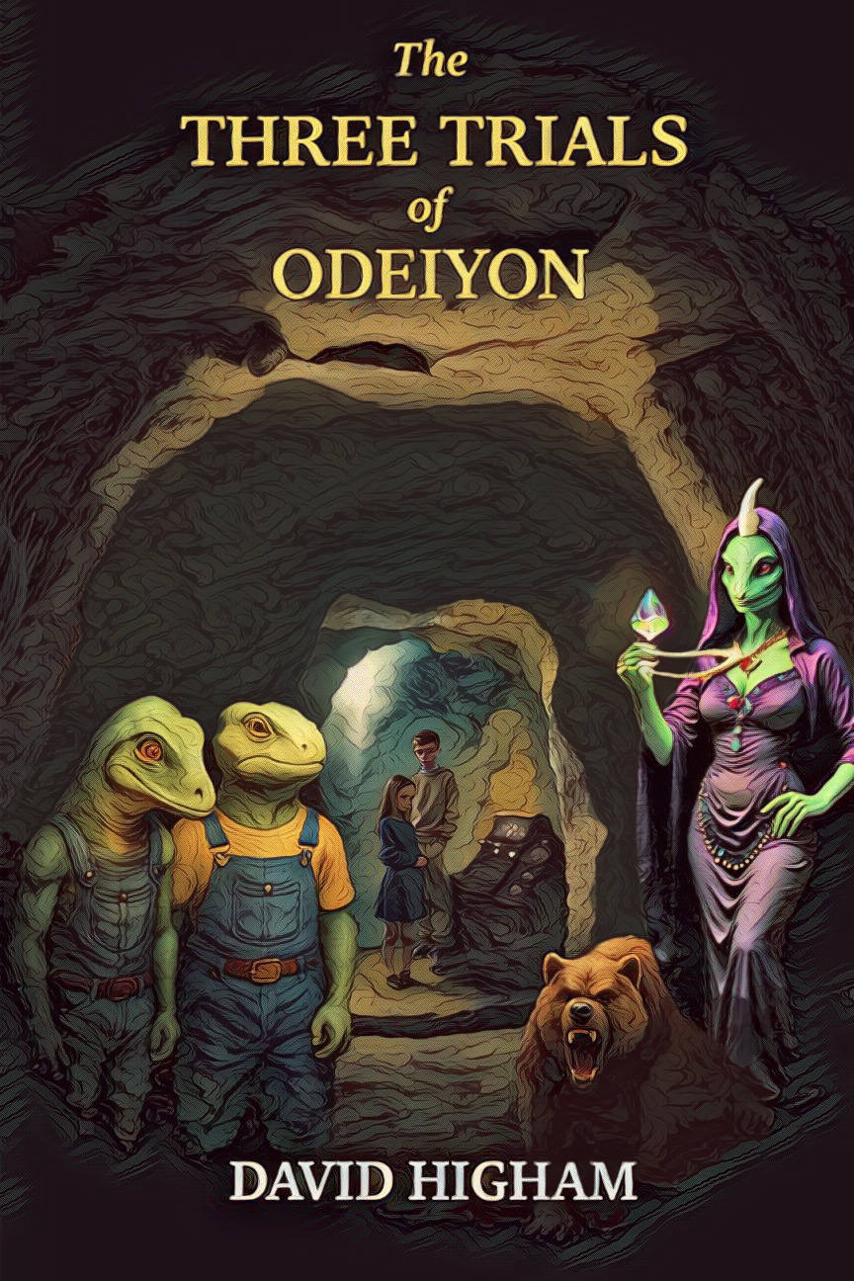
A Dedication (with a bit of history)

This book began some years ago, a few years after my children were born, with the simple notion of including their names into a story. At that time the new exciting idea of a home computer was to attach a small plastic box (aka the spectrum or commodore or oric, etc) to a tape recorder (there were no disks), a spare portable T.V, and a typewriter with some electronics and a parallel interface (the really old geeks will understand).

Add hours of playing around with leads trying to get the system to work, more hours of amateur story creation, really awful sketches to serve as illustrations and a very understanding wife, together with the (then) developing idea - ebook marketing - and you end up with something that achieves two quid in sales and the justification to call yourself an author.

Eventually circumstances changed and this project resurfaced. The result is a bit better. There are more interesting elements to the story. The illustrations are very good. But I am still rubbish at marketing, so I won’t do it. The book is offered as a free read and I am satisfied if it provides a bit of thoughtful fun.

I dedicate these poor efforts with love and blessings to my son and daughter who are so inaccurately represented in this book for the sake of storytelling.

It is also dedicated to those that they love (including their mum – big time) and all of their families and friends.

And in turn to those that they love and so on to the power of ten thousand.

And also to those that they don’t love - perhaps because they are less lovable or just a bit mean - because let’s face it, their need for love and blessings is greater.

And not just the people they know, but all people in every community, however weird, dodgy or wonderful we find them.

And not just the people, but the animals, who also need love and blessings, sometimes even more so.

As well as the grapefruit, the carpet, the stars and everything else that we have forgotten that we are really a part of.

Love and blessings to them.

Oh crikey, I guess I’ve even included the politicians…

Whatever.

THE THREE TRIALS OF ODEIYON

Chapter One

The Game and the Pit

He spun around to see where the sound had come from. A rustling in the bushes gave the answer. In the shadows behind the curtain of leaves, he could just make out her face. Lifting a branch, he scrambled in until also hidden. Neither spoke, hardly daring to breathe as the sound of footsteps grew louder, stopping just a few yards away. For a moment they held their breath, fearing that they had been discovered. Then the footsteps continued, passing them by. Both could relax again.
Andrew winced as he tried to unhook a bramble. Jennifer gave a nervous giggle, but her brother just looked indignant. He poked his head out of the bushes. "It's clear now. We'll run over to the rocks before she comes back and finds us."
They crawled out from their hiding place and ran. Andrew reached the rocks first, but then he was more than two years older than his sister, who had only just passed her eleventh birthday. By the time she had caught up, she found him sitting behind one rock, throwing small stones at another, looking rather bored.
"I'm bored."
Jennifer just grinned and sat down beside him. They both looked across to the next hill, where a tired sun was finally coming down to rest after a magnificent summer’s day. There were no real clouds, just the now usual white trails left by some aircraft, the ones that seem to go on forever until they expand, but never quite dissipate.
"I suppose we'd better get back."
"Well, at least we escaped," said Jennifer, changing the subject. "Is she really a witch? I think she must be. She looks like one to me."
Andrew laughed. "I don't suppose so. She looked O.K. to me. A bit crabby, maybe."
"She's definitely one of them, though. You saw the badge on her coat, didn’t you?''
''Sure, but everyone’s a ‘lookout’ now. Who isn’t, nowadays?''
Both Andrew and Jennifer knew well enough what they were. They were the reason that their parents had been away so long. After the government’s ‘Progress through Co-operation’ scheme was launched, everyone was encouraged to be a lookout, by receiving a small reward and a badge of merit if they reported a neighbour who might be behaving or talking in a suspicious way or against approved guidelines.
Over the last year it had been noticed by one of their colleagues at work that their parents had been discussing some very different ideas. Then an information access check by the Peoples Trust Support Group had decided that they had spent too much time looking at unofficial material, which had left them vulnerable to misunderstanding. A refresh course was the answer.
It had now been over a month since their parents had been gone, when they had been enrolled on the government’s revision course. This was encouraged and freely available to anyone who chose to renew their understanding and commitment to the system. By taking part, they would be reminded again of their duty as good citizens.
It was not as if their parents didn’t know all this anyway, as the same messages were inseparably woven into the theme of mostly every film, show or news bulletin. But none of this had seemed odd to the children. They had already learned about the need to support the system. Both had watched TV since they were toddlers where such messages were a repetitive theme. It was just that by now they were missing their parents.
''I wonder if we’ll hear anything this week'' mused Andrew.
They had been assured that the course would only take a few weeks, so they had been sent to stay for a while at the Children’s Support Hostel. It was explained to be like a holiday while they discovered new places. But that was over a month ago and nothing further had been heard.
Jennifer plopped down beside him, now also feeling sad. ''Bound to. Anyway, we’ll get some kind of message soon''
''Maybe. I’d like someone to give us an idea of when they’ll be back. Someone. Or something. Anything to help us find out what’s going on''
''Something’ll turn up''
''Don’t be stupid.''
''You’re just mad I hid better. Bet you’d scream if the Witch caught us.''
''Would not. But you might!'' Andrew retorted. They gazed at the hill opposite, where the sun was finally deciding to rest for the day. ''We should head back. They’ll freak out if we’re late again.''
Jennifer’s face lit up. ''She’s back!''
They scrambled over the rocks, Jennifer spotting a narrow gap between two boulders. ''In here!'' she whispered, squeezing through feet-first, her sneakers scraping the stone. Andrew crouched behind another rock, peering out. The footsteps faded again - false alarm. He turned to call Jennifer, but only a mop of tangled hair and a smudge of face were visible in the gap.
''Come on, Jen, let’s go,'' he said, exasperated.
A crack of twigs, a yelp, a thud and - Jennifer was gone. Andrew’s stomach lurched. He rushed to the gap, peering into the shadow. ''Jen! You okay?''
A moan echoed up. ''Ow… my ankle.''
Andrew leaned over to see. There seemed to be a hole where she had fallen, but it was way too deep, the shadows swallowing her. ''Where are you?''
"I don't know. It's very dark in here - and spooky." It was apparent from her voice that she had fallen quite a long way. Looking around, Andrew wondered what to do. Help was needed.
He scanned the area. The lady was long gone, and no one else was around. ''Hold on!'' He climbed above the stone, bracing his back against one rock and pushing the other with his feet. His sneakers slipped on the dry sandy earth, but he gritted his teeth, muscles straining. Slowly, the rock budged, then rolled a little, doubling the size of the gap
Now he could see Jennifer, several feet below in a sandy pit, rubbing her ankle. The sun now cast a golden ray through the entrance, lighting her bruised but determined face. ''You okay?'' he asked.
"S'pose so," she answered, trying to stand up. "Now that I can see where I am, ‘though I bet I have lots of bruises. Luckily the ground's very soft down here."
''Try your phone,'' Andrew suggested.
Jennifer unbuttoned her pocket and pulled out the 'phone. It was still working, well protected by its padded case. After a couple of tries, however, it was clear that it wasn’t going to work.
"No signal – even with that new mast on the lane."
She reached out her hand, which Andrew just managed to touch. It was obvious that he wouldn't be able to pull her up. Peering inside, however, he found that the front wall of the pit wasn't a straight drop, but more of a slope which could easily be tackled. Jennifer must have rolled down, which was why she hadn't hurt herself so badly in the fall. In no time at all, Andrew slid down to her, landing with a spray of sand.
Surprisingly, they could really see quite clearly inside. The setting sun had lined up with the entrance, and a ray of light shone straight through, until it came to rest on a wall of rock. Looking around, the pit was really very large, and high enough to stand in, although Andrew scraped his head more than once on a particularly awkward overhang. Craggy stone made the walls and ceiling, but the floor was deep with sand and debris.
Then they noticed the strangest object. Sitting in the sand, by the furthest wall of the pit stood something shaped like a large box, but jet black. The leaves and twigs - which were generally scattered around the floor - covered the top like camouflage. It had obviously been there for some time. Still it seemed peculiar, and totally out of place.
They went over to explore, and Andrew brushed off some of the mess with his hand. There was writing underneath! Quickly, they both scratched away the remaining dirt from the surface. Although not rusty, it must have been made of metal and was obviously a device of some kind. There was a small display screen, with inset squares forming a pattern to one side. Above this were the words ‘PATHS MAY CROSS, BUT MUST NEVER MEET‘.
"A stupid thing to write," said a puzzled Jennifer. "What do you suppose it means?" But Andrew had no idea what the writing meant.
They were both wary of touching it, and should have done the sensible thing and left the machine well alone. It wasn't theirs, and there was no telling what it was for. But this didn't seem to belong to anyone, and the setup did look a bit similar to a really large old games console that had been left in a corner of the garage at home. Andrew had played with that before, so he knew how easy it was to use, even though it was awkward and now too slow for his latest games. It wouldn't really be so wrong to see if this worked in the same way, would it?
He was wrong, of course. Nevertheless, soon he was prodding at each of the squares, and generally pressing and poking the contraption to see if anything would happen. A few minutes later, having no success, he scowled and turned to Jennifer. "Probably broken, or perhaps it needs power."
Jennifer was disappointed too. "I'm not surprised it wouldn't work after being kept in this cold, dark place," she said, as she brushed down her dress and started to walk back to the entrance.
Almost at once the machine began to make a low humming sound. She turned and rushed back in excitement, but the noise just faded away again.

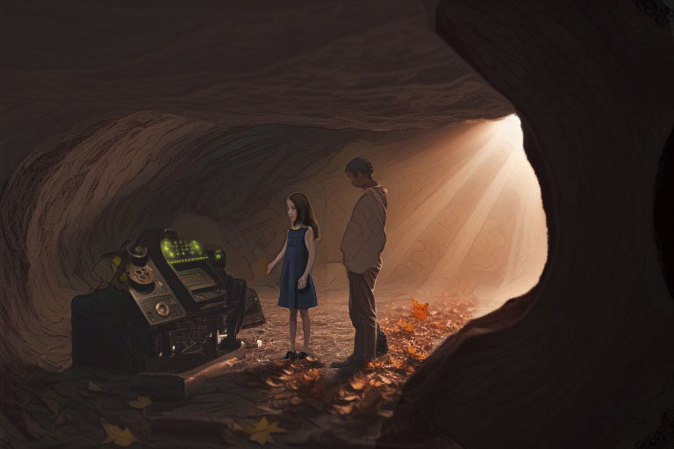

"It's the light!" exclaimed Andrew. For he had noticed, that as Jennifer moved away from the machine, a ray of light from the sun had fallen directly onto it. When she returned, the path of light was blocked again, leaving the machine once more in shadow. Andrew too was in the way. He moved to one side, and immediately it began to hum again.
Gradually, the display began to flicker, until one word was clearly visible. Neither of them knew what it meant, or even if it was a proper word at all. The word was 'IMINNODES'.
"Try pressing something again," whispered Jennifer, as if she might be overheard. Andrew pushed the first square. The word disappeared from the display and another, every bit as confusing - 'ENDOORACTI’ - took its place. Underneath this appeared a long string of numbers. After a while the display cleared, without anything further being touched, and the first word came back. He pressed the second square, and then the third, each time with similar results.
The same happened when he pressed the fourth square, but now, after staring at it for a few seconds, Jennifer recognised something. ''It's a clock!''
She was quite right, it was a clock. At least, the last few numbers seemed to give the time, down to the changing seconds.
Andrew looked at his watch to see if it was accurate. "Your right," he admitted. Then he noticed the first set of numbers on the line. "There's the date," he said, pointing them out (and making the most of noticing that bit before she did). ''Look, the year, followed by the month, and then the day.''
The display changed back once more. "Well, that's really useful," he remarked, rather sarcastically. On pressing the fifth square, yet another set of numbers appeared. But this time, getting bored with just watching rows of numbers, Andrew wanted to change something. Before the display cleared, he pressed the first button again, four times. The last four numbers all increased by one. Andrew was not impressed. "It's just an overgrown calculator."
So he pressed the big square button at the top.
Just then the world dissolved.
Neither Andrew nor Jennifer really knew what happened. They must only have blanked out for a few seconds, but it seemed so much longer. There was the strangest, overwhelming feeling that their bodies had lost any kind of shape or sensation, but seemed to be everywhere at once. At the same time, all around them went very dark. It was too late to try turning it off , before anything even more dangerous could happen.
Because it already had.

Chapter Two

Rinborch and Werrocks

The world snapped back into focus, but it wasn’t the pit.
Andrew blinked, his head spinning like he’d just stepped off a rollercoaster. The air was warm, thick with the scent of flowers and something like overripe fruit. He stood in a garden, lush and sprawling, with hedges carved into spirals and fountains gurgling under twinkling lanterns. Jennifer was beside him, clutching his arm, her eyes wide as saucers.
There was a great deal of noise, of shouting and laughter and music, as if a party was in full swing. Shadowy figures silhouetted against the bright glow of windows. Andrew opened a wrought iron gate and started up the cobbled path. Suddenly, Jennifer stopped still in her tracks, tugging at Andrew's sleeve. At first he couldn't understand why, until he saw what she was staring at.
In front of them stood one of the strangest creatures that they could ever have imagined. Standing slightly taller than Andrew, it resembled a giant lady lizard, but with a shining horn in the centre of its forehead! Dressed in a ridiculous glittery costume, and adorned by oversize jewellery, it was an extraordinary sight. Two enormous eyes bulged out from behind a pair of pince-nez glasses (they couldn't really have been any use, and anyway must have been quite impossible to wear, as the creature had little to call a proper nose).

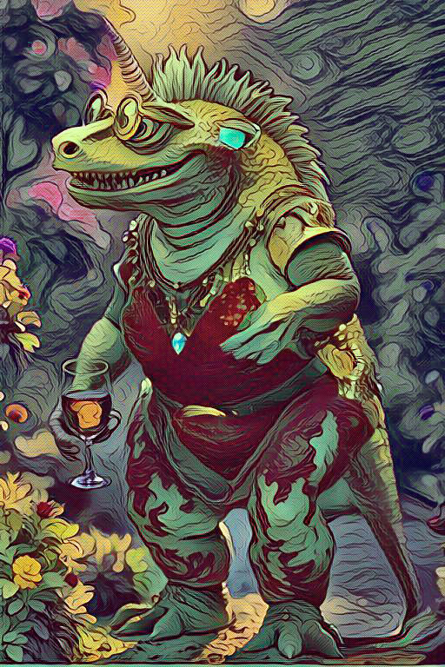

''Where are we?'' Jennifer whispered, her voice barely audible over the chatter and clinking glasses around them.
Andrew shook his head, trying to clear the fog. ''No clue. But that machine… it did something.'' He glanced back, half-expecting to see the black box, but there was only a stone path leading to a massive house—three stories of gleaming windows and ivy-draped walls. Music drifted from inside, a weird mix of flutes and something that sounded like a cat being strangled (but it was a violin).
People—or not quite people—mingled in the garden. They were tall, with various shades of green or grey-green scales glinting under the lanterns, small tails flicking beneath ornate waistcoats and gowns. White horns protruded from their heads, polished to a shine, and their eyes were sharp, like they were sizing up everyone for dinner. Andrew’s stomach twisted. These weren’t humans.
''Jen, look at them,'' he muttered, nudging her. ''Are they… lizards?''
Jennifer squinted. ''Kinda. But fancy ones. Look at that guy’s hat—it’s got feathers!'' She pointed at a creature in a velvet top hat, its plumage bobbing as it laughed with a vowel-heavy accent, all ''oohs'' and ''aahs'' like it was auditioning for an opera.
By now the strange lady creature had spotted them. "Wort enimel are you?" it suddenly shrieked at the children. Both Andrew and Jennifer were too terrified to reply. "You lorst tongue?" it shrieked again.
Andrew had just recovered enough to answer. "We're children. What are you?" The creature pretended to shake with laughter, turning to the others in the garden, who by now were all showing an interest in the proceedings.
"Why, em I a Rinborch orf course, you steewpid thing. You cen't tell a Rinborch when you see one?'' The creature raised her head high in the air. "We all Rinborch here."
The other creatures said nothing, but just looked down at the children with disdain. This was turning out to be difficult. It was hard enough to believe that all this was really happening, or whether it was just some kind of bizarre trick or fantasy. But trying to talk with an animal which seriously confused vowels...
"End wort do you doo?" asked the creature.
"Do?'' said Jennifer "What do you mean?''
"Doo!" replied the creature testily. ''Doo! Wort do you doo for a living?"
"We don't do anything" answered Andrew. Then, to phrase that just a little better, "except for lessons and homework, I suppose."
"Oh, you intellectuals," said the creature. "Thet explains your strange appearance." The creature turned to her friends. "They all very odd, you know." The other creatures nodded wisely in agreement.
"And what do you do?" asked Jennifer, innocently, trying to make polite conversation.
The creature shrieked again. "Doo?" she said, waving her long arms, and spilling most of the drink from the glass she was carrying. "This whet we doo!" And all of the other creatures joined in, laughing, running around, spilling drinks, and generally falling over each other.
Soon forgotten, the children went indoors, where it seemed to be quieter anyway. In one corner was another Rinborch, sitting in an enormous armchair. He seemed very placid compared with the others that they had left outside, so Andrew plucked up some courage and approached.
"Excuse me," asked Andrew in a soft voice, just in case this one also became hysterical.
The Rinborch looked up and started giggling. He seemed dazed, staring into the distance. It was as if he hadn't even noticed that anyone was there.
"Excuse me," Andrew tried again, "but could you tell us where we are. It's just that we're late out as it is ..."
"Where are we? We are here!" the Rinborch exclaimed, between giggles. "Why, we are all living in the land of Dococulouck!" With this he burst into uncontrollable laughter.
Andrew looked at Jennifer. "This is hopeless," he said. "We're not getting anywhere. What shall we do?"
Before Jennifer could respond, a crash rang out. A tray of glasses hit the grass, and a smaller creature—smoother-skinned, no horns, in plain blue overalls—dropped to its knees, scrambling to pick up the shards. The fancy lizard-people barely glanced over, except one, who sneered, ''Clumsy werrock! Back to the kitchens!''

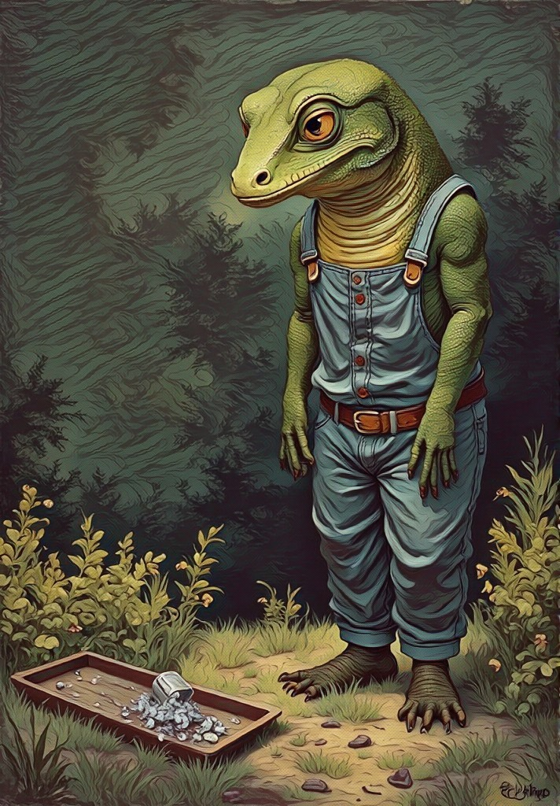

The werrock, as the servants were called, was shaking, its head bowed. It grabbed the tray and bolted toward the hedges, leaving a glass behind. Jennifer’s chest tightened. ''That’s not fair,'' she said.
A young servant girl, maybe twelve, darted past, balancing a tray of drinks. Her smooth skin was a softer green, and her eyes were bright, curious. She paused, glancing at the sad werrock’s retreat, then at the children. ''You’re not from here,'' she whispered, her voice low. ''Stay quiet, or the Rinborch’ll notice.''
''But what is….?'' Andrew was asking, but she was already weaving through the crowd, her tray steady.
Jennifer tugged his sleeve. ''Bet she knows something. Let’s follow''
Before they could make a move, another creature loomed over them. ''My deear friends,'' it drawled, vowels dripping like syrup. ''Guests of the Grrreat House, yeees? Come, join the festiviteees!'' Its clawed hand gestured to the house, where more Rinborch laughed and sipped glowing drinks.
Andrew hesitated, but Jennifer, ever the adventurer, nodded. ''Sure!'' she chirped, then whispered to Andrew, ''Let’s play along, or we’re toast.''
Inside, the Great House was a maze of chandeliers and velvet curtains. Creatures lounged on deeply cushioned chairs, their jewellery clinking like wind chimes. Andrew tried to mimic their stiff posture, puffing out his chest, but tripped over a rug, earning a few sniggers. Jennifer stifled her laugh. ''Smooth, Andy. Very cool.''
At a window, Andrew noticed the sky - clear, but in the moonlight he could tell it was streaked with odd clouds, shaped like long strings of white popcorn. A Rinborch clapped its claws, calling for a toast. ''To proooogress!'' it boomed, and the crowd echoed, but the servants’ faces were blank. Andrew’s skin prickled. This place was wrong—beautiful, but wrong. They had to get out, find answers, and figure out what that machine had done to them.

They slipped out of the Great House, the party’s music fading behind them. The Rinborch didn't even notice the children leaving, being far too interested in themselves to worry about anyone else.
The night air was cool, but the streets were anything but welcoming. Cobbled lanes twisted between grey stone buildings, their windows dark except for flickering lanterns. At one time they noticed a very fierce-looking creature across the road, muttering to himself. They decided to give him a wide berth.
Without warning, a hand grabbed Andrew’s shoulder. He yelped, spinning to face someone he immediately recognised - smooth-skinned, with kind but tired eyes. It was the servant who had dropped the tray at the party. Still dressed in his overalls, he beckoned them to follow. ''You two don’t belong here,'' he said softly. ''Come with me. Name’s Ernor.''
Jennifer hesitated, but Andrew nodded. ''Better than getting caught by Scales McGrumpy back there.''
Ernor led them through alleys to a somewhat dilapidated house just beyond the edge of town. Its paint was peeling, but the garden was alive with herbs and flowers, glowing faintly under the moon. They followed their host through a short hallway into what was used as the living room. There was a smell of bread and something earthy. The room was sparsely furnished, with a wooden table in one corner, a tatty welsh dresser in another, and three wooden chairs. A fire crackled, and an elderly woman sat at the table, grinding herbs.
''More strays, Ernor?'' she said, her voice warm but sharp. ''These ones look like they’ve seen a scaly hooray or two.'' She winked, her wrinkled face creasing with humour. She introduced herself as Mirium, Ernor’s mother.
Jennifer grinned. ''That’s what you call those Rinborch? Perfect.''
Ernor chuckled, setting out bowls of stew. ''Eat. You’re safe here. Now you can tell us, how’d you end up in Dococulouck?''
Andrew explained—the pit, the machine, the dizzying shift. Jennifer added, ''And those Rinborch are mean. What’s going on?''
His mother’s eyes darkened. ''The Rinborch rule here. They have control – over everything. The shops, what we can do, where we can go, everything.''
Andrew’s stomach knotted. ''Why do people put up with it?''
Ernor sighed. ''It’s just the way things are. Most are happy to be left in peace, to make the best of things. As long as they feel well fed and entertained, that’s enough.''
''Entertained?''
''Yes, some diversions to fill their time. Like getting small things to make their home look pretty, or watching shows and games on the visual transmitter, that sort of thing. But Rinborch manage everything - food, water, work, and of course, the broadcasts. They say what things are scarce and need to be rationed, but their houses overflow with everything they want. People just believe everything their told. More werrocks are starting to catch on, though. There is a group, called the Calidras, who leave messages for us to read. But of course that’s illegal. The rulers call it vandalism or hate twaddle and any notices are quickly taken down again.''
Jennifer perked up. ''Like secret heros? Cool!''
Mirium laughed. ''Cool, but dangerous. If they are ever caught, you don’t hear from them again. Even talking about their ideas can land you in trouble. Anyway, we’re safe out here. Check the garden tree. It’s often used. Might find something.''
Outside, under moonlight, Andrew and Jennifer found a gnarled tree with carvings: *TRUTH LIES BELOW. DON’T TRUST THE PLAN.* The words glowed faintly, like they’d been etched with some chemical.
''Creepy,'' Andrew said, but Jennifer was thrilled. ''It’s a clue!

Back inside, Ernor looked grim. ''That machine you found- it’s no toy. For many, many years the Rinborch have been digging and working underground. Some say that’s where many more of them live. You might’ve stumbled onto one of their secrets. The best thing is for you to see the Doonby as soon as possible.
Andrew looked puzzled. ''What’s a Doonby?''
''A friend, He knows so much more than we do. We have an old saying here – Doonby knows the truth. I can't take you today, for it's a very long way to Tilbyre, and we must prepare for the journey. We can leave tomorrow, if you like."
"Is Tilbyre the place where the Doonby lives?" asked Jennifer, hopefully.
"No, not there," replied Ernor. "He wouldn't live in that place. He is a recluse, and lives by himself between the settlements of Tilbyre and Bothex."
"That place?" asked Andrew. "It sounds as if you don't like Tilbyre very much."
"Neither Tilbyre nor Bothex are to my liking," replied Ernor, "and with good reason."
"Why?" Jennifer was now becoming concerned. Perhaps they weren't as safe as they had so far supposed.
Ernor stared hard into the dying embers. The fire reflected in his eyes. "They are the two largest cities in Dococulouck," he continued, "named after the royals of the Crown Coven - the Warlock Tilbyre and the Witch Bothex. The rulers are greatly revered in those cities, even worshipped by some, but I fear others have not fared so well. They have to be obeyed"
"Are they cruel?" asked Jennifer, now a little frightened.
Ernor thought for a moment before answering. "The Coven creates our laws. Many believe that they are doing good, by passing laws that allow everyone to do as they please. It's the rule there, that no-one can be forced to do what they don't want to do, or be made to stop doing whatever they like."
This didn't seem to be so awful, but the children were still concerned to know about any dangers that may be waiting ahead.
"Then what is so terrible for the people who live there?" pursued Jennifer.
"Many are happy because there are no rules," answered Ernor.
"And many are sad because there are no rules," added Mirium.
"Some can't live as they want," continued Ernor.
"Because others can do anything they please," added Mirium.
There was a long pause as the children tried to understand, without much success. Eventually Jennifer broke the silence. "So how far is it? To the Doonby, I mean."
"With fair progress, I would expect the trip to take a couple of days."
Both children were taken aback. It would be ages before they would get home! But still Ernor insisted that there was no quicker way, and right now they had to trust his judgement.
''Rest tonight. Tomorrow, Tal will arrive with his wagon. He knows the way.''
It was exciting to learn that they would be travelling by horse-drawn carriage. As they curled up on blankets by the fire, they were thinking about all the ways that seemed so different here, yet so many things reminding them of home. Jennifer whispered, ''Andy, are we really in another world? What if it’s not…?''
Andrew shivered. ''Don’t be weird. But… yeah, we gotta find out.''
The fire’s glow felt warm, but the carved words on the tree burned in his mind. Whatever Dococulouck was, they were in deep - and the Doonby’s truth was calling.

Chapter Three

Tal and Tilbyre

The morning sun was barely peeking through the grey haze, casting long shadows over Ernor’s garden. Andrew yawned, rubbing sleep from his eyes, while Jennifer poked at the embers in the hearth, her hair still tangled from the night. Mirium bustled about, packing a sack with bread and other food and drink that would help on their journey. Ernor stood by the door.
''Tal’s late,'' Ernor said, glancing at the road. ''He’s never late.''
''Why don’t you ‘phone him?'' asked Jennifer
She then spent what seemed forever trying to explain what she had meant. They had never been aware of such things as telephones. Ernor was even less impressed when she showed him her ‘phone, or more precisely her useless little black box, as it was now totally discharged and could show nothing. Of course the demonstration would never have gone too far in Dococulouck, which had no towers to transmit a signal. In any event, Ernor explained that the postal service was generally reliable, although he did admit that ''sometimes letters do get mixed up here.''
''Anyway, we’re ready for the journey. It's all done," continued Ernor." I spoke with Tal late last night. He had to get the wagon ready, but I’m sure he won’t be long now.''
''You saw him last night?'' asked Andrew. That was quick! Do you know him well?''
''Well enough. He’s my brother. Just lives down the road.''
"Will you be able to take the time off work?" asked Andrew, for the first time thinking of their host.
Ernor looked away towards the ground. "That will no longer be a problem. They won't have me back again at the Great House."
"But that's so unfair!" cried Jennifer. "When all you did was spill some stupid drinks!"
"That's as may be," replied Ernor, sadly. "But the Rinborch must be served without any fuss. A good servant should never be noticed."
Andrew was also finding it hard to hide his irritation. "What is it that makes the Rinborch so powerful?" he asked. ''They don't seem to do very much. And they talk so strangely!"
Ernor looked back towards them, but he seemed distant. "As I said, it's just the way things are. They make the laws which then protect them. The younger werrocks have never known anything different. Rinborch own mostly everything. They were given all their position and wealth by the Crown Coven, many years ago.''
''So what is the Coven?'' asked Jennifer. ''Are they really witches?''
''Oh yes, they’re real enough. But as werrocks, we really know very little, as knowledge about them is kept very secret. Some say that they originally lived somewhere else, that perhaps some of them still do. We just don’t know. Most werrocks don’t even know that the Crown Coven exists. The only royals we see are the Witch Bothex and the Warlock Tilbyre, who were appointed by the Coven to oversee us.''
''And the Rinborch really talk weird''
''Yes, some talk in a strange way and they think it makes them sound impressive. But not all of the Rinborch are so bad, you know. Some can be very nice. Many spend their time doing all sorts of useful things, and of course they hold nearly all of the important positions. It's just that they don't really need to do anything, if they don't want to."
Ernor tailed off. He had very mixed feelings himself about what had happened. ''Anyway, you’ll find that Tal will be a good friend. He’ll keep you away from Rinborch eyes. That machine you found - it’s stirred something. The word has already got out. Soon, I think, a lot more people will be interested. And we all need answers.''
Before Andrew could ask any more, hooves clopped outside, and a sturdy wagon rolled up, pulled by a horse that looked as tired as Andrew felt. A werrock leaped down—tall, broad-shouldered, with smooth green skin and a grin that said he’d seen trouble and laughed at it.

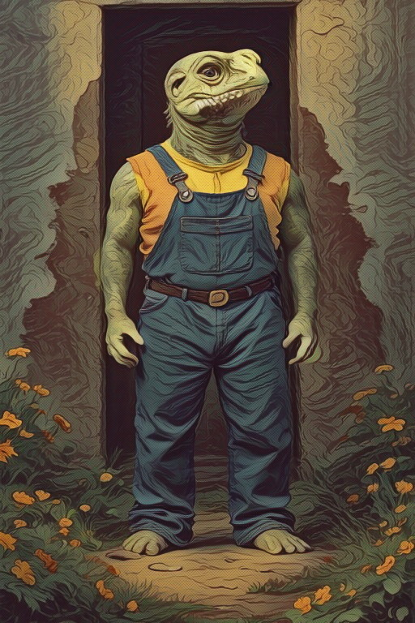

''Ernor, you old lizard!'' he called, clapping Ernor’s shoulders. ''Got your strays ready?''
''Tal!'' Ernor’s face lit up. ''Meet Andrew and Jennifer. They’re… not from here.''
Tal’s eyes sparkled as he sized them up. ''Not from here, eh? You look like you fell out of a storybook. Hop in – it’s warming up now and we’ve got a long road ahead.''

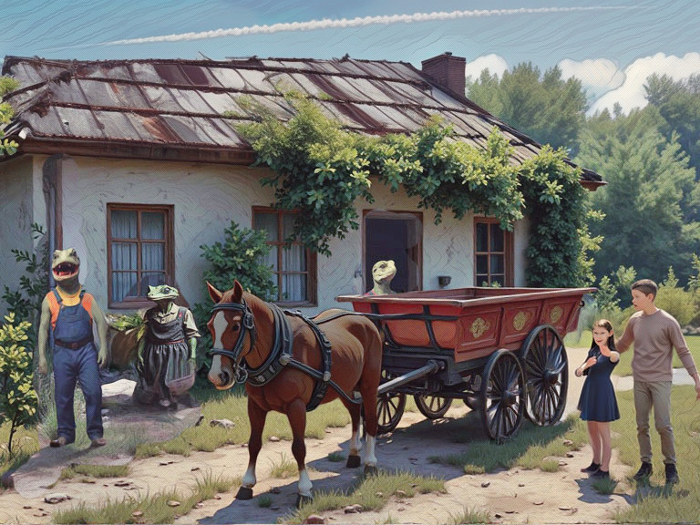
Jennifer scrambled onto the wagon, bouncing on the wooden seat. ''Can I drive? I’ve seen it done enough in movies!''
Tal laughed, handing her the reins. ''Sure, kid. Just don’t send us into a ditch.'' Andrew climbed up, muttering, ''Great, we’re gonna crash.''
Sure enough, Jennifer yanked the reins too hard, and the horse snorted, veering toward a bush. Tal grabbed the reins, chuckling. ''Maybe watch a few more, eh?''
As they rattled along the bumpy road out of town, the streets grew quieter, but the air felt heavy. Werrocks shuffled past, some sniffing, their eyes squinting at the sky. Andrew followed their gaze up to the long white lines that didn’t fade, as they slowly spread across the sky Ernor’s jaw tightened.
''They call those clouds ‘progress’. We call ’em trouble. Ever since that started, a lot of people have been complaining. Can’t sleep, asthma, coughing, forgetting things. All sorts of problems. We’ve also been told that some sickness is going round, so people were ordered to take medicine to keep it from spreading. It could be the clouds that make us sick, but we just don’t know. And the medicine - that’s probably even worse than the clouds. Some say it’s all because of weather changes. Perhaps – we don’t know any more than we are told. All we do know is that it’s another secret, and the way I see it anything that is kept secret is kept secret for a reason. And that can’t be good.''
Tal added ''Food’s scarce and a lot more expensive, too—they ration us, telling us what to eat, and claim that the old crops don’t grow anymore.''
Andrew frowned. ''Why doesn’t anyone do something?''
''Who? It’s not easy. As I told you, most werrocks just believe what they are told. Speak too loud, and you can soon end up with no friends and in big trouble.''
By late morning they passed a house. It was the first building that they had seen for many miles, and it meant that they were now approaching the furthest outskirts of Tilbyre.
What seemed more important at the time, however, was that it heralded the arrival of a track, soon to become a lane. This meant that some degree of comfort and speed was again possible, much to everyone's relief. Tal’s wagon may have been handsome, but it was only made to carry farm supplies, so was never designed to carry passengers on such a long journey. Over the miles the wooden benching had made them all pretty sore, even if they didn’t like to say where.
After travelling down this lane for a while, they were forced to stop. A pile of heavy logs had fallen from a broken cart, which now lay abandoned in the ditch. There was no way that the wagon could get through.
In a field nearby sat several werroks, chattering and laughing. Perhaps they didn't see the travellers, or deliberately didn't notice. Either way, they ignored Tal's shout.
"Hey, you there!" he called. "Is this your cart?" Tal jumped down from the wagon, and walked over to the group.
"Is that your cart?" he repeated, sternly.
"Yeah, it's ours," one finally replied, casually. "'Least, we were driving it."
"Then why don't you move the logs?" Tal demanded. "You must know they're blocking the road. We can't get through."
The spokesman shrugged his shoulders. "Can't help that. Those logs are too heavy for us to lift."
"What nonsense!" exclaimed Tal. "Surely between you, you could manage to move them."
"’Fraid not," replied another. "There's no way I'm goin' to lift any of that. Anyway, it's not our job, see."
Tal was impatient, and not convinced. "You spilled them, the least you can do is try to move them out of the way."
The spokesman turned his back, shrugging his shoulders again. "Not us. 'Spect someone will move them. Eventually."
By this time Tal was very angry, and probably would not have let the matter pass but for Ernor. He knew that their first duty was to help the children, so wanting to prevent any trouble, he spoke quietly to his brother. Reluctantly they returned to the wagon, trying to ignore the sniggering of the group behind them.
The children climbed down to help. The logs were too heavy for them to lift, but they managed to roll some of the smaller ones out of the way. Ernor and Tal were stronger, of course, and together could even manage to lift some, but still it was hard going and a tremendous amount of effort for everyone. Everyone, that was, except for that indolent group, who just sat in the field giggling and whispering remarks to each other. Tal never heard what they said, but that was their good fortune.
When they eventually finished, and there was just enough room for the wagon to pass, Ernor shepherded them all back on board.
Nothing was said. They were all tired and upset, and Tal was still very angry. It was a while before Jennifer broke the stony silence.
"Why didn't they help? It was their cart that broke down, not ours."
"It wasn't really theirs," replied Ernor. "They were just being paid to move stuff for someone else''.
"Why even use them" asked Andrew, "when they couldn't lift the logs? They should have given the job to someone stronger."
"Oh, they probably would have," said Tal, grimacing, "But that still wouldn't make any difference. You can’t choose anyone or even expect them to help in Tilbyre, It’s the law. You just look after yourself."
After a few more miles they had all but forgotten the episode. The lane had become wider, until now it could fairly be called a road. It was a very uneven road, however, full of bumps and holes, and had obviously not been repaired properly for some time.
The same seemed true of the fences and buildings that they passed. It was as if nobody was bothered enough to do anything here.
As they got closer to the city, it was noticeable how quickly everything was becoming dirtier and seemed more unfriendly. At one time they passed two werroks who were trying to paint the outside of a house. One sighed as she sat at the base of a ladder, looking extremely distant. The other leaned precariously from his position half way up the ladder, brush in hand, splattering paint from an outstretched arm. The result was awful. Streaks of colour had missed the window frames, and were dripping down the brickwork. The children stared in amazement, but neither Tal nor Ernor seemed a bit surprised.
Many other times they would pass small groups of werroks, often very young, perhaps climbing on walls, or kicking a fence, or anything else just to fill the time. Some looked menacing, but most just seemed to be without any inclination or idea of what to do, though if they managed to annoy someone that was considered to be a bonus.
After what seemed another forever of sitting on the hard bench of a bumpy wagon, Tal announced that they were nearly there. It was then that a figure stumbled out from some bushes. Scaled and horned, it should have been scary, except that it was dressed in a mismatched robe that screamed ''I got dressed in the dark.'' Rings clinked on his claws, and a scroll slipped from his grip, rolling into the dirt. ''Blast it!'' he muttered, scrambling after it.
''Varnok!'' Ernor exclaimed, leaping from the wagon. ''What’re you doing here?''
''Heard you were coming'' replied Varnok, dusting off his Rinborch scholar robe, after the hem caught on a branch. Andrew bit back a laugh, but Jennifer giggled outright.
''Careful, professor,'' called out Tal.
Varnok’s scales flushed a darker green. ''Undignified fieldwork,'' he muttered, then thrust the scroll at Ernor. ''We now know that the Coven are hiding things underground - machines, vats, silos - filled to the brim. We must find them!'' His eyes darted to the sky, ''and those clouds… they’re not just water.''
Varnok continued, lowering his voice. ''I can’t prove it yet, but it’s all connected. Take this map. There are so many tunnels. They lead everywhere, maybe to the machine you saw. I hear you’re hoping to reach the Doonby. Give this to him. He knows you.''
''Well done, Varnok my friend. This will be very useful. Now get back before they notice you’re gone.''
Varnok nodded, tripping over his robe again as he vanished back into the bushes, while Ernor tucked the scroll away.

The wagon rattled into Tilbyre’s heart, where the streets buzzed with tension. Once inspiring red brick buildings loomed over cobbled lanes packed with werrocks. There were the youngsters hanging around on street corners trying to look tough, old men sitting on doorsteps, some with a begging cup. Others were scurrying by quickly, perhaps to get home with their shopping, while some passed slowly in order to fill the day. Dogs and other animals ran loose amongst the litter. Andrew’s nose wrinkled at the smell—sweat, smoke and sewerage. Jennifer leaned over the wagon’s edge, her eyes wide. ''This place is a mess.''
''What's that noise?" she asked suddenly.
It was difficult to listen. The clattering of wheels and horseshoes against stone drowned most of the sound. They could hear something, though it wasn't possible to tell which direction the sound came from as it echoed around the buildings - a low, rumbling noise, not unlike thunder, but continuous. Was it getting nearer?
They were still trying to decide just what the sound might be and where it was coming from, when all at once it found them. In a few moments scores - maybe hundreds - of Tilbyrians had spilled into the street from around the corner. Werroks and Rinborch alike were chanting, yelling and waving banners in a triumphant fury.
The shock of the sudden din and movement startled everyone, even the redoubtable Tal. The horse whinnied frantically, retreating back into the wagon. Tal grabbed the reigns and tried to drive them out to safety, but it was already too late. The mob was now only yards away, and began to surround them.
There was nowhere left to go.
Some small stones hit the wagon, thrown from somewhere deep in their midst. Ernor and Tal tried to screen the others as much as they could, but then one of the stones hit the poor horse. In panic it shied, knocking over some of the crowd as it did so. Then the leathers snapped, and the horse was free. It bolted, scattering bodies and making a furrow through them. The travellers were left stranded.
The force of the crowd shoving and pushing was now so strong that the wagon began to shake. Tal made a grab for Andrew, lowering him to the ground. Ernor followed with Jennifer, and the four tried to push their way through to safety, through jeering and abuse, "Get the strangers!" screamed one, pointing to the children.
They had almost reached the entrance to a narrow alley when Ernor, who had been trailing behind, was knocked over, and almost trampled into the ground. Andrew saw what had happened and rushed back, flinging his arms into the crowd as he went. He took some of them by surprise. They fell backwards into each other, making them more enraged than ever.
"What do you think you're doing?" snarled one, picking himself off the ground and staring at a confused Andrew. ''Just what are you, anyway? You’re not one of us!''
"We've got to find our horse. Your shouting scared her away!"
"We can do whatever we like."
"You're smashing the cart," shouted Jennifer, giving Ernor her arm. ''Stop it and leave us alone!''
"So your pretty paintwork is knocked about. What's that to us?!"
Ernor sensed danger. "Come on!" he called, grabbing Jennifer's arm. "We must get away!" They all ran as fast as they could, as far as they could, down one alley after another. It was several minutes before they dared to stop again, fearing that they might still be pursued, but no-one was following.
Perhaps the mob had been left behind, or perhaps they had decided not to follow. Either way, it seemed that they were safe for the moment.
Tal was terribly upset. His horse had gone, his lovely wagon was broken and now they were all lost, without food or support. Both Tal and Ernor still had a little money in their pockets, however, enough they hoped for a night's lodgings. And so on they trudged through the backstreets, looking for some cheap tavern where they might spend the night, to recover and perhaps reflect on how they could possibly now reach the Doonby.

Chapter Four

Capture

Eventually they came upon an Inn, dilapidated and obviously very old. Yet it looked clean enough, and under the circumstances it seemed both convenient and affordable.
The atmosphere inside was gloomy, but calm compared to the streets that they had left behind. Several werroks sat drinking, but there was no conversation. It was time for the programs, and the only sound to be heard came from a visual transmitter in the corner. A broadcast was starting and the image of a shining gem appeared on the screen. The customers all stopped in mid conversation, transfixed by the glow of the screen. Ernor and Tal had seen this before and urged the children to look away.
They walked up to the bar, and Tal beckoned to the proprietor. In a low whisper, he explained their needs for a room for the night. Even this interruption brought a cold glare from the regulars, and so for nearly an hour they all sat quietly at a table, not daring even to order a drink.
After that time the programs had mercifully finished. They had been a mixture of repetitive announcements, news bulletins and short clips of what passed for entertainment, each designed to satisfy a small attention span. Programs here were created to capture an audience at any price, continuously moving the boundaries of what might be considered acceptable. Once attention had been assured, it was easy to persuade an audience to any changing ideas. The result was popularity for the coven and public approval for every new proposal. At times the elder locals looked uncomfortable. They were clearly unhappy with the programming and could still remember when dignity was more highly valued, but those days were long past, and had never been experienced by some of the younger werroks. Newsreaders and entertainers alike would be well rewarded for as long as they showed support for the regime, to belittle any dissent, to offend, and thus become famous.
At one point a short news bulletin showed the demonstration in which the travellers had earlier taken such an involuntarily role. Such 'spontaneous' demonstrations were frequent, and always encouraged by the rulers. The pictures showed the brave and righteous youth of Tilbyre
declaring their freedom and allegiance to the ruling Coven. The younger regulars of the Inn were enthusiastic in support. There was no mention of the disruption caused to Ernor's wagon and its occupants.
At last food and ale could be ordered, with a fruit drink for the children, as Ernor knew from experience that the local drink would prove unsuitable. As always they accepted his decision (though perhaps Andrew would have been happy with a second opinion).
The meal was welcome, if rather stodgy. When satisfied, they settled back into the deep cushioned chairs to rest sore and aching limbs. They were too tired to talk much themselves, but the inn was now alive with conversation and argument, and the travellers had no energy left to avoid listening.
Of all the strange things in Tilbyre, it seemed that what they then overheard was the most odd. It wasn't so much that the conversations were nonsensical, but the children knew that they had already heard most of it before, and it didn’t take too long before it dawned on them. All of the views they heard were just as expressed in the broadcasts moments before. There was hardly one original thought amongst them.
The chairs were comfortable, and they were beginning to fall asleep when Jennifer noticed a stranger in uniform arrive. He said something to the proprietor, who gave no reply, but nodded towards their table. Then he left, so Jennifer thought no more about it.
Within minutes he returned, but this time accompanied by three guards. They marched straight up to the travellers.
"Come with us!"
Ernor and Tal looked up wearily to see who was doing the talking. Andrew was already fast asleep. Jennifer said nothing, waiting for one of the brothers to reply.
"Come with us. Now!"
Tal wouldn't be intimidated by official bullying. "What do you want? We've done nothing."
There was no answer. Instead they were all grabbed and pulled abruptly out from their seats, making Andrew cry out, being awakened so unexpectedly. Without explanation they were thrown outside, and marched through the streets. The children had no idea what was happening, but they could see that the brothers were more angry than scared. Ernor tried to give a reassuring glance, but without much success.
Five more minutes brought them to a drab grey building. Inside, they were pushed down an iron stairway, along a narrow corridor, then into one of a score of tiny rooms which it serviced. The door slammed behind them, and there was a metallic thud. They were locked in!
The room was quite unfurnished, with the exception only of two benches, loosely covered with some dark brown blankets. Being in the basement, there was no window, and a dull electric light did little to relieve the gloom.
For the first time since they had found Dococulouck, Jennifer found it hard to hold back some tears. They had come so far, and been through so much already, yet they had always coped. But now things looked hopeless, and she wished that she could just find herself back in her own bedroom, comforted in the knowledge that her family was there to protect her.
Ernor held her arm. "No need to be upset. They're only the local guard, you know. They wouldn't really hurt us."
"Then why have we been brought here?" sobbed Jennifer. "What have we done wrong?"
"Nothing, I'm sure. We're bound to be released in the morning. Until then, at least we've got a roof over our heads. The best thing that we can do is try to get some sleep."
Which is exactly what they did.

It was still the early hours when the door burst open. A giant figure filled the space that was left. He bellowed only one command.
"Out!"
Covers were torn away from the beds. Ernor and Andrew were hauled up into the air, still half asleep. They both collapsed onto the floor, but at least this gave Tal and Jennifer some chance to wake, so that they managed to scramble to their feet before it was their turn.
All four were ushered out into the corridor. There was no word of where they were being taken, or why. Pushed again down the long passageway, they came upon another iron staircase, which spiralled upwards through a square hole in the ceiling. The guard shouted something, then, one by one, pushed them up the first few steps. Although now fully awake, they still felt terrible - unwashed, dishevelled and hungry.
Looking like scruffy vagabonds they emerged, eyes screwed up tightly against the unaccustomed brightness. As they grew used to the normal light again, they began to focus on their new surroundings. They were in a room, a crowded oak-panelled hall, standing in an enclosed rostrum (Jennifer could only just see over the top). At one end of the hall sat a score or more of Rinborch and werroks, some studying the proceedings attentively, some just talking amongst themselves, one even fast asleep. At the other end of the hall sat several elderly dignitaries, each absorbed in volumes of notes as if there was no-one else in the room. Between and above them all sat a young Rinborch, adorned in bright silken robes, offset only by a long off-white wig which almost completely veiled her head. The sides of this projected out so far, that the only time her face could be seen was when she looked straight at you. It must have had the same effect on her own vision.
Gradually the hum of chatter died down. All eyes were now on the pulpit. "How do you plead?" called one of the officials, trembling as he tried to overcome his obvious nerves.
None of the travellers knew what to say. Eventually Tal decided that some reply was needed.
"What have we done?"

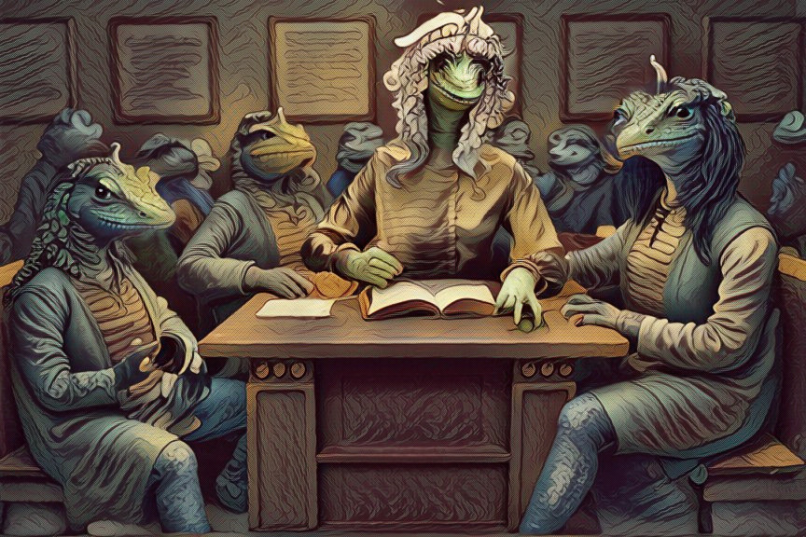

"How dare they!" screamed the young Rinborch. "Send them to prison! Hang them!"
One of the officials hurriedly arose and whispered something in her ear. She scowled, then reluctantly nodded. He returned to his seat and addressed the travellers once more.
"You are charged with blatantly contravening the first law."
"Nonsense!" cried Tal. He turned to Ernor. "How did we do that?"
They didn't know. It had been a long time since either of them had found it necessary to visit Tilbyre, where what was regarded as right or wrong never stayed the same for very long. The current official view was always to be found in the broadcasts. Perhaps they should have paid more attention to them the night before.
Tal's question had been overheard. Another of the officials cleared his throat. Holding both lapels of his waistcoat, he raised himself to his full height (which wasn’t very high).
"You must know our law," he said, holding up some papers high enough to show that he was quoting from them. "Everyone has the right do as they please, and no one can be what another cannot." Looking very pleased with himself, he sat down again.
Tal was familiar with those words, or something very much like them. "That’s simply a bad rewording of the original Deed of the Heart, one of Dococulouck’s founding testaments", he said. "But those were about describing the need to show concern for others. They were never meant to be enforced as law. You can't legislate or condemn people for the way they think!"
The official rose to his feet once more, pleased for the attention. "It is now the first law of Tilbyre, passed at the last meeting of the Coven."
The young Rinborch was suspicious. "How you do know so much about our founding documents? Who are you?"
Tal introduced himself and his brother, and then the children. He didn't explain how they had met, or why they were travelling. It seemed best to give away as little as possible.
Ernor, who had been shuffling about uneasily, pulled at Tal's sleeve. Tal had understood the message, but already one of the officials was leaning over to the young Rinborch and whispering something. She nodded, staring hard at the brothers.
"So, Tal and Ernor, is it? And me tell, was who your father?"
Tal raised his head and stared straight back at her. His tone was clear and defiant. "Odeiyon. We are his sons."
For the moment there was silence, then the courtroom erupted with excitement. Andrew looked bemused at Jennifer. Neither knew what all the fuss was about.
The young Rinborch glared at the two brothers, but said nothing. Eventually she turned to the children again. "We will deal with your crime first."
Yet another of the officials looked up from his papers, then stood to speak. "The charge is that these creatures," he began, pointing at the children, "attacked our law-abiding residents of Tilbyre, when all they were doing was celebrating..." (trying to recover his breath in his excitement)...the new laws that our glorious Coven had passed !"
This accusation brought a volley of jeers from the public gallery. None there had seen children before, and it was easy to accept that they should hold weird and harmful ideas. Not that it had anything to do with the charge, but that didn't really seem to matter.
Jennifer was now very upset and looked to Ernor for help. He gave an assuring smile, putting a finger to his lips. It was best that she didn't say anything until they had learned a little more, but the prosecution had other plans.
"Did you or did you not," continued the official, "Say that these citizens" - he now pointed at the crowd - "could not continue to celebrate as they wanted?"
Andrew wasn't repentant. "Yes I did. This mob were throwing stones and pushing us around. They wrecked Ernor's wagon, and goodness knows what's happened to the poor horse!"
The official looked sheepishly at him. "Ah... I see... that is..."
"Nonsense!" cried out the young Rinborch. "These fine people are not a mob, they are victims. It is not right that our youth should be repressed. They must show the way forward, to support our progress. If anything was damaged, that is your fault. Surely can't you expect these innocents to be accountable for what happens to your precious property?"
"It was their fault what happened," Jennifer interrupted. "They shouldn't have done it!"
"Enough! Send them to prison!" screamed the young Rinborch again, jumping to her feet and waving her arms furiously in the direction of Jennifer and Andrew. "They said it! They are guilty!"
Immediately the guard reappeared. Both children cried out as they were grabbed, hand-cuffed, then pulled away through the jeering crowd. In horror they looked back to the brothers, who were now being restrained by several armed guards, and could only look on in helpless desperation.
In a matter of moments the children were marched outside, and into the back of a waiting van. With blaring sirens it raced off, taking the children away from their friends, and away from the only hope they had of ever returning home.
Chapter Five

In Custody

In the courtyard of Tilbyre gaol, the short rest break provided a rare opportunity for the children to dwell over their misfortune. Some days had passed since the trial, and most of their time so far had been spent on very unpleasant cleaning duties, both inside the buildings and in the yard. This had left little time for brooding, which was probably all to the good, for by now they had begun to lose hope of ever seeing their family or friends again.
The work had also kept them apart from the other inmates, who were generally kept occupied on excavations and road repairs. The separation had been quite intentional, not because the children were considered unsuitable for the heavier work, but because the warders were still afraid that they held some kind of influence. The warders had never seen humans before, so they were bound to be treated with a great deal of suspicion. But at least they had been kept together, for which there was good reason to be thankful. Still they wondered what had become of Ernor and Tal, and wished that their friends were there to guide them.
As it turned out, their wish was to be granted sooner than they expected. At the far end of the courtyard appeared a figure, bedraggled, but upright and quite unmistakable.
Excited, the children rushed over. Tal was obviously delighted to find them unhurt, and quickly confirmed that he was also in good health, though very worried about Ernor.
"Where is he? Wasn't he brought here with you?"
"Yes, but then he was taken for questioning," replied Tal. "the authorities know who we are, and they are certain that we have come to cause trouble."
The brothers had disclosed in the courtroom that they were the sons of Odeiyon. Now the children listened in astonishment as Tal explained that many years ago his father had been the last free leader of their province, and a sworn enemy of the Coven. Odeiyon had led his region for some years, trying to show how it could be ruled under the now redundant doctrine of consideration for all. He had tried to show how the people could lead a better life by helping each other, instead of relying on the Coven. But all this had come to an abrupt end when once more the Coven was elected into power. The people had been generally happy with the qualities of life that the old way had provided, but Dococulouck had never been a land of great wealth, and many were finally swayed by many promises of riches and the abolition of all of the existing laws. This last promise had been kept, although there had never been much intention of honouring the others.
One thing the people could never have expected, however, was the ruthless way by which the Coven ensured that Odeiyon and his supporters would never return to power.
Immediately after taking control, the Coven hunted down their rivals mercilessly. Many disappeared and were never heard of again. No-one really knew what had happened to Odeiyon himself, although there were many rumours. Some said that he had been murdered by his enemies, but the official story was that he had fled the country in shame after his defeat. Whatever the truth, neither the brothers nor their mother had seen him from that day. With help from some close friends, they had escaped from the cities, and settled down far away in a remote shire where they should never be discovered. There Ernor and his mother had stayed, rarely venturing further than the local village, until the arrival of the children. Tal had moved out some time earlier, accepting the job of running a local farm, where he would work incognito until once more the family could be recognised.
The reunion was interrupted by the sound of a loud bell. Tal sprang to his feet, knowing that there would be trouble if he was late for his duties. Without time to explain further he raced off, promising only to see them again as soon as he could.
The children also had to get back to their work, but now with spirits raised. Ernor and Tal were near, and hopefully soon they would all be together again. Still, it would have been good to see Ernor, to know that he was all right.
Two days later Tal was out with his working party when a thud in the centre of his back knocked him quite off balance, so fierce that he fell to the ground. Already hot and tired after several hours' digging, he glared up to see who was responsible. To his surprise it was one of the inmates who bent down to help him up again, a small and very scruffy werrok, obviously wary of Tal's reaction.
"I'm only a messenger," he stammered. "I had to find a way to talk to you."
Tal struggled to his feet, a fierce stare showing that he was still annoyed.
"There's going to be a break," the werrok continued nervously. "You're getting out!"
"I'm not going anywhere. Now get out of my way and don't bother me again."
The little messenger was shaking, but persevered. "You must go. The Calidras need you."
"I'm not going anywhere. My brother's here and he needs my help."
"Ernor will be coming as well. It must be soon, or it will be too late."
"What do you mean?" demanded Tal. "Why will it be too late? What's going to happen?"
By now they could hear a warder coming, and the wretched creature was beginning to panic.
"Your brother won't be kept alive for much longer. You must leave here soon. Very soon."
Tal didn't know what to say. If this was true, he had to help Ernor immediately. Yet he couldn't just leave the children, they were relying on him. He didn't want to join the Calidras either, but they all needed to get out if they stood any chance of continuing their journey, and now there was the possibility that Ernor was in danger of his life. They all had to be helped somehow, and Tal hadn't yet thought of a better plan.
"Alright, I'll come," he replied, "but only if the children come too."
"But that's impossible!" the little werrock hissed, now terrified of being caught by the warder.
"They must come as well, or we cannot join you."
At that moment the warder reappeared. The small werrok staggered as he lifted a rock, pretending to move it. He played his part well, and the warder was not suspicious. He glared at them both for a moment, then carried on past. Tal picked up his shovel again, hoping that he had done the right thing. The messenger meanwhile had disappeared from sight.

That same evening, Tal was just preparing to settle down to sleep, when there was an explosion so loud that he jumped out of his bunk to see what was happening.
It was distant, probably on the other side of the prison, but so fierce that it shook the floor and walls. Immediately sirens began to scream, and people started running along the corridor.
The sound of the blast quickly died, until all that could be heard beyond the alarm was a general commotion in the distance. Then the door flew open, and there stood the messenger again. He threw a parcel at Tal's chest.
"Put this on, quickly. It's a warder's uniform. Hurry, there isn't much time."
Tal didn't argue and put on the uniform as quickly as he could. Then he followed his guide into the courtyard - only to find himself thrust into a group of warders! Instinctively he froze, not knowing what to do.
The group started to make their way towards the main gate, with Tal trapped amongst them. Ahead was yet more commotion, and it was just possible to make out what was being said. Someone was being carried out on a stretcher, covered by an old blanket.
"Let us through. He's been injured! Get him to the hospital quickly!" The party ahead were allowed through and soon disappeared.
Now Tal's group was nearing the gate. He didn't understand what was going on, but it was all part of the plan. One of the warders rushed up to the guard at the gate, and was immediately acknowledged.
"The children have escaped. We must get them back."
The gates opened, and the group ran through, Tal still amongst them. All feelings of panic had left him now - it was difficult to believe that this could be happening.
Outside the gate the group split up. Tal was taken firmly by the arm and led down a rambling overgrown path. They ran as fast as they could in the darkness, using their arms as shields against the scratching overhang of branches and brambles.
Eventually they slowed down, and Tal could regain his breath. The coldness of the night air and the sound of some water lapping nearby keened the senses. There was some light ahead. From out of the darkness, a river glistened beneath the diffused moonlight, against which lurched the silhouette of a small boat. Someone was already on board and without a word a hand reached out and helped Tal across. There were no lights, but the low coughing of an engine signalled their slow departure.
With a final push against the muddy bank, they moved off. Tal was shaking now, and sat quietly at the stern, finally submitting to his feelings of relief and bewilderment, but still tempered by the fear that they may be stopped at any moment. He sat back and smiled to himself, trying to recover his composure. Then he saw the stretcher on the floor, and the figure covered by the blanket. It was Ernor! Tal knelt down and touched his brother's shoulder. There was no response. In fear, Tal called over to the helmsman.
"He's not moving! Is he alright? Is Ernor ill?"
"He'll be fine. But he's been heavily drugged, and won't wake up again tonight. Best just to let him be. And get some rest yourself."
It was difficult to tell much in the dark, but Ernor didn't seem at all well. Tal pulled up the blanket to ensure that his brother was properly covered, then lay down alongside, by now so tired that he fell asleep almost immediately.

The misty rays of the reborn sun shimmered behind the uppermost leaves of the trees as they passed, and even the decaying timbers of the unkempt boat seemed fresh again in the cool morning air. It was a moment before Tal recalled where he was and what had happened.
Ernor was still fast asleep, though now looking content and comfortable. Tal unsteadily sat upright to check their situation.
They were well into the countryside by now, and the helmsman confirmed that good progress had been made during the night. Evidently their destination was now close at hand, at least as far as the helmsman was concerned, for soon the boat would be met by more members of the Calidras. Ernor was showing signs of coming around. His eyes flickered, screwed up tightly against the morning. He recognised Tal and they both smiled. They said nothing.
After a while Ernor tried to speak, but he could do little more than move his lips. Tal helped him to sit up, propping him awkwardly against the side, and carefully started to explain all that he knew. Ernor nodded to show that he understood.
Before long they disembarked, to be met as the helmsman had promised. But even here the Calidras feared to be seen, which meant that there would be no horses for transport, with several hours walking ahead.
The going was very hard, for the Calidras would avoid any pathways. This was made all the more difficult at first, for poor Ernor was still quite dazed and unsteady on his feet. After a few miles, however, he had all but recovered, and was able to tell his story.
Despite being drugged repeatedly, and allowed no rest, Ernor had still been unable to tell the authorities what they wanted to know. They had been certain that the brothers were preparing to lead some kind of revolution against the Coven, which of course was untrue. Consequently Ernor could tell them nothing, despite all their skills at interrogation, and so eventually they had to believe him, and had decided that he would be of no further use.
They were still too afraid to release the brothers, however, and their plans that the brothers would never be allowed to leave had been overheard.
The guide stopped as they reached the brow of a hill. He turned and grinned, pointing down across a valley and explained that they had finally arrived.
Following the line of his arm, one could just make out a grey stone cottage, nesting in a clearing between the trees. Even then they would easily have missed it, except for a thin spiral of smoke in the sky which pointed down to the chimney. In front of the cottage stood several werroks, and amongst them two easily recognisable figures. The children were already there!

Chapter Six

Reunited

They hurried down the hill as fast as they could, and in no time at all had reached the cottage. Some came forward to meet them, Jennifer and Andrew included.
The rest of that day was taken up with so many tales of heroic deeds to be repeated time and time again. So it was much later in the afternoon when the old friends finally managed to escape the general hubbub for a while, and found themselves a quiet corner of a nearby field where they could listen to the children’s' story.
The children recalled how they had already gone to bed when a deafening explosion wrecked the wall just outside their cell.
Almost immediately, through the debris and clouds of dust, two werroks in uniform burst into the cell and grabbed them. The children never knew what was going on, and all they could remember throughout the commotion were clouds of dust and debris.
With no time to resist they were thrown like sacks of old rags over broad shoulders, then rushed outside to be dumped on to the back of an old cart. Without waiting, the wagon jolted on its way, and never once stopped until the following morning, when it arrived at the cottage. Jennifer had scratched her leg as she was thrown onto the back of the wagon, but surprisingly both escaped any serious injury.
Tal rose to his feet and suggested that it was time to join the others. The day had now come swiftly to a close, and the Calidras had already gone indoors.
Everyone had to stoop on entering the cottage, the door was so low. Inside it was dark and very gloomy. The place had not been painted (or maybe even cleaned) for some years, and by now all the shutters had been closed, to prevent any light betraying their position to the outside world. In the hallway they found a table, upon which was scattered all that remained of supper. Each took a tankard of ale and a pie (there was no choice) and made their way through another small door, behind which raised voices could be heard.
There was no light in the room, save that from a large fire which crackled and burned its way unevenly as it joined the conversation. Around sat a score or more of the Calidras, some on tables, some on the floor, a few in chairs.
Every now and then a burned log would fall in the fireplace, throwing out sparks and a sudden bright light that picked out faces otherwise hidden in the darkness. A musty smell blended with the wood smoke, which was very tiring on the eyes.
The Calidras had been arguing about what should next be done, but now there was a hushed silence. Those sitting on chairs shuffled over to make room for the brothers. Tal and Ernor accepted, and the children knelt down on the floor beside them.
The only sound remaining was the movement of the fire, and of course two children hungrily eating. It was a while before the silence was broken by a timid voice, coming from somewhere in the shadows.
"So what shall we do?"
Tal looked around to see where the voice had come from. He couldn't tell, but it didn't matter anyway. "You must realise," he answered, "that we don't want to fight the Coven. Our father is gone now."
"But you must help us!" cried another. "We helped you."
"No," replied Tal firmly. "We have another job to do. We have to take these children to meet the Doonby."
An elder slowly arose and took his position in the centre of the room. The Calidras were a disparate though tightly knitted group, brought together by circumstance after each one had lost family or suffered personally from the Covens rule. But until then it had been apparent why they needed leadership so badly. There had been no-one to turn to when a decision was needed. But here was a member that at least held their attention, perhaps because he had seen so many campaigns, or perhaps he was just respected for the wisdom that comes from advanced years, usually a reason for derision in Tilbyre. In any event he spoke, and for now, at least, they listened.
"The Doonby," he explained, presumably for the benefit of those too young to have learned much of the old conflicts, ''was a mighty Wizard. It was he that supported Odeiyon during his rule, and if it is true that he is still alive, he would surely be a source of great strength to us. If the sons of Odeiyon are to see the great Wizard, we would be wise to join them."
No more was said on the subject. The brothers thought it best not to argue, although they would undoubtedly have preferred to continue the journey alone. The decision had brought a new air of excitement into the room, and before long the cottage rang with the sound of laughter and song. For tomorrow was a thought away, and tonight they would celebrate their victory.
It was the following evening before the travellers could resume their journey. This time, however, they were accompanied by two members of the Calidras, and each had been given a small horse to ride. Neither Andrew nor Jennifer had any experience of riding until that afternoon, when Ernor had supervised their first lesson. Of course the Calidras never used saddles, relying instead on woven mats which, it has to be said, provided a surprisingly good grip and a comfortable ride. The children, however, were still a little uncertain as they sat bolt upright whilst being led round in circles, and they were already beginning to ache from the exercise.
Nevertheless, as dusk fell, six mounted figures dutifully started on their way from the cottage and into the wooded valley below. The Calidras had insisted that they travel at night, a time when they always felt more secure. They were all expert navigators in the dark, and could pick their way almost silently in the shadows without fear of the horses stumbling.
The air was cold, but refreshing. A stiff breeze pushed a patchwork of clouds across an otherwise bright moon, causing the uppermost branches of the trees to sway and rustle, as if they couldn't keep a secret. The peace of the night was occasionally interrupted by something baying or howling, but the travellers paid little attention. While they were together and on horseback they felt safe, and glad for the companionship of their two guides. They rode in single file, with one of the Calidras in front, and one at the rear. This avoided the possibility of any horse stumbling, as they followed in the sure footsteps of the leader, for in the half light and shadows it was often difficult to see the ground.
Although travelling still further away from Tilbyre, the Calidras insisted on keeping to the shadows of the woods and in the valleys. They had long ago learned to distrust, and wished to meet no-one. At one time a night bird screeched in a branch just over Ernor's head, startling him and his horse so much that he almost fell off. He was quite embarrassed, and try as they might, the children just couldn't stop giggling for some time, which annoyed the Calidras, who took a very dim view of the silence being broken.
All night long they rode, and then well into the next morning. The children especially were tired, and when they finally stopped for food, it was decided that the rest of that afternoon should be given to sleep, while the Calidras took turns at keeping watch.
That evening they set off once more, again to ride through the night, but now in the knowledge that they were close to their goal. It was shortly after dawn when they came to the edge of a precipice, and for the first time the children saw where the Doonby lived.

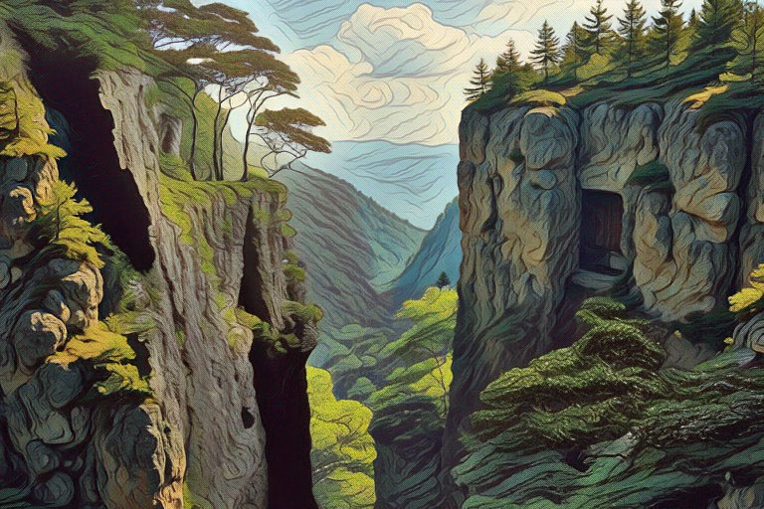

The cliff dropped so far that even the mighty trees on the ground below seemed like bushes, and the thought of being so high made them want to hold on to something, even when they kept back from the very edge. Across a narrow plain rose another rock, every bit as steep as the one they were on. Tal pointed to a strange irregular wooden door about three quarters of the way up. It was the entrance to the Doonby's home.
"What a fantastic place to live!" exclaimed Andrew.
It certainly was breathtaking, having a grandness which was a contradiction to its simplicity. Having heard so much about the Doonby, the children hadn't known whether to expect a castle, or some kind of hermit's hovel, and it had never seemed appropriate to ask.
How to get there would be another problem, but there would be no choice. For the remainder of the morning they rested, before beginning the awesome descent to the narrow plain below. This would only be possible on foot, so they decided to leave the horses grazing in the safety of the pastures above.
It didn't take as long to reach the bottom as they had expected. Instead, the overriding problem turned out to be maintaining a controlled rate of descent whilst staying more or less vertical, of which they had only limited success.
Once down, it was very difficult to see how they could ever climb up the next cliff to reach the door, for there was no ladder or path in sight. But the brothers had often visited this place as children many years before, and still remembered the secret. They led the way along the base of the cliff for a while, then disappeared behind some rocks. Behind these a ridge of stone sloped upwards, and then another, and so on in large irregular steps.
Excitedly the children and the Calidras followed, which was tough, especially for Jennifer who had to be hauled up the steeper steps (some came up to her chest). But this was no time for faint heart. They had come too far.
Well before dusk fell they were standing outside the great door of the Doonby. Ernor tugged at a large vine hanging to one side of the door, and the muffled sound of a gong echoed from somewhere deep in the heart of the mountain.
There was a dull click, and the door moved slightly ajar. It took all Tal's strength to push it open. Nobody was there. He called out, but received no answer.
Warily they entered, and made their way down a long winding corridor. The walls and floor were made of solid rock, but this was brightly polished, and at regular intervals a large crystal had been inset, emitting a pale blue glow which reflected against the surrounding stone.
Each footstep echoed alarmingly, although evidently no-one heard, despite Ernor's continued calls.
Eventually one turning opened out into a cavernous room, brilliantly lit in almost every colour imaginable. Crystals were scattered by the dozen around the walls and on the ceiling, some shining light blue, some yellow, others a brilliant white. The floor itself shone with different coloured marbles, whilst the walls were streaked with various shades of stone. Such work could well have graced a King's palace, but this was a monument that had been crafted by nature.

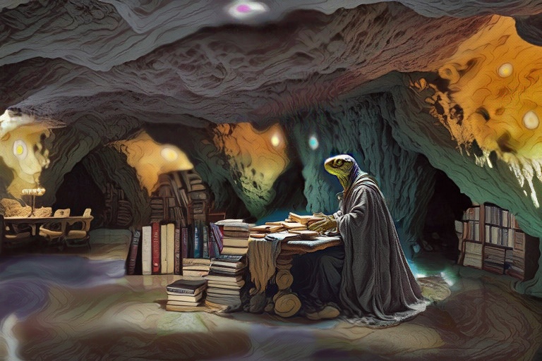

In the centre of this sat a small, frail figure, stooping over a table piled high with books, which spilled over the edge and onto the floor. Yards of coarse grey material hung upon his thin frame. Piercing eyes set deep in a sallow face stared coldly through the intruders. He grunted as they approached, then scowled.
"Go away!"
They all froze, quite taken aback. The two Calidras remained nervously behind in the passageway. Tal was the first to recover.
"Don't you know who we are?" he asked, hopefully.
The Doonby stared at him with suspicion, but said nothing.
"I'm Tal," he continued, rather hurt. "And this is Ernor."
Squinting hard, the Doonby peered over his papers. Suddenly his expression and tone changed. "Tal and Ernor?" Bless my soul! Come in! Yes, come in!"
The old friends now greeted each other warmly. At the Doonby's bidding, everyone helped to push some large stones nearer to the table, and even piled up some of the books in order to provide makeshift seats.
The Doonby, now keen to learn the nature of their visit, listened attentively whilst Tal recalled the arrival of the children, their eventful journey and capture, and how they had been rescued and joined by the Calidras. The Doonby was totally absorbed in everything that he heard. He waited until Tal had finished, then addressed the children.
"So now I know why you have come. You must long to return to your home."
He turned to the Calidras. "You still seek Odeiyon, and perhaps even my help in your fight with the Coven. But what makes you so worthy of this power that you seek?"
Until this moment the Calidras had remained silent, sensibly waiting for the opportunity to submit their earnest request. Their fight against the tyranny of the Coven was a passionate one, and they were certain that any power or support that could come from the old leadership would ensure their success. Now one of them spoke up.
"We wouldn't claim to be so worthy, sir, but the Coven must be stopped. Yes, we want power, to deny those who crush others in the name of freedom. Power to restore the pride that has been lost. Will you help us, sir, or do you support their rule?"
The Doonby shook his head. "The Coven was elected, was it not? Surely this is what the people want."
"Do they? Just because the Coven was once given authority, it doesn't mean that what they do is right. Promises were made, but never kept. They brainwash the people to meet their own ends. They keep all the wealth, when most have so little. They will only act when they need to silence the few that stand up to them. That doesn't mean it's what most people want."
"And why do you think you could do better?"
"Because, sir, the wrong people have the wealth and the power. We would change all that."
The Doonby smiled, acknowledging their sincerity, but doubting their understanding. "I recognize it's what you feel you must do, but I have fears that you may only substitute one problem for another. Does it really matter which tyrant rules? There will always be those that gain, and those that lose."
He then turned to the brothers. "You are not lost, and have long sworn an oath against revenge. What is it that you want of me?"
Ernor replied, aware that the Doonby already knew the answer. "Yes, we promised never to bear hatred. We promised that we would forget the old struggle and protect what was left of the family. But we still remember the stories you told us, and when the children arrived we decided to help them."
The brothers had heard so many stories during their earlier visits to the Doonby, when as children they accompanied their father on visits to his friend. As a young rebel Odeiyon had learned about the old writings. They had been passed down from a once great civilisation, called the Drowwlen Order. These documents were said to hold the key to the true secrets of freedom.
The Doonby, now taking full advantage of his rare audience, delighted in recalling something of the legend. His title had been inherited, as custodian to the manuscripts previously entrusted to generations of his family. These documents were all that now remained as evidence of a people that had accumulated so much power through technology that it could not be contained. The Drowwlen became proud that they had unravelled the secrets to life and the universe, but they finally learned that their knowledge had outgrown their wisdom, until their creation eventually replaced its creator.
The final manuscript gave a detailed account of the final destruction, of how their technology that had been invested with power became so great that eventually nothing was left for it’s creators to achieve. Everything was bountiful and provided through the management of technology by technology. There was no role left for the Drowwlen. They had become redundant, useless.
Having committed everything to writing, a guard was appointed to protect their legacy. The final words of the last page read 'Where the truth is to be found, Doonby knows.' And so, having heard of this, and seeking freedom himself, Odeiyon had gone to the Doonby. There he learned of the way to true knowledge, and decided to accept the challenge of the trials.
"Trials?" asked a concerned Calidras.
"The Drowwlen said that they had left three paths to gain a higher wisdom, which would be learned through trials." He opened the volume he was holding and began to read:
"We must first learn that possession and division are the same thing. Belongings are temporary, and can only bring a passing joy. The strong learn how to walk away. The contented give when others would only take.
Secondly, we must know that our physical senses will deceive us. They restrict the world by our fears and our hopes. Let us look beyond the picture of evil that we see. By replacing what we accept as true with what we feel in our heart we can release the good.
Finally we must bury the past. Let all errors be wiped clean, as everything must end before the new can take its place."
He looked up. "The trials teach what the Drowwlen never learned. Wisdom must be acquired. To understand truth you must live it. That is why the machine was created. It seeks out those who are ready to learn, and sets them on those paths that will teach them. Over the years many have been called. Some have taken the challenge. Odeiyon alone had returned."
"Was he so strong?" asked one of the Calidras.
"In his own way," replied the Doonby.
"Why should we go?" asked a now very anxious Jennifer. "What good is it to us?"
"You will see, and very soon." The Doonby continued his reading: "Each trial is a lesson, that we all need to learn. The lesson has been taught many times before, in many different ways, but rarely has it been understood. Every student will be enrolled again and again, until the lesson is mastered."
The Doonby lifted his eyes to see whether any of his audience understood. It was unlikely. He turned the page and continued:
"Be warned, for it is not a game. The trials can bring joy, but are sometimes unjust and dangerous. Of fair play expect none. Rights and justice are no more than inventions. Beware of our inventions, for they may be our downfall. They can entangle us, even replace us and are an obstacle to learning. By letting go of this confusion, we can grow in understanding. Those who face these trials as children, with no cause to win and nothing to lose - they are the ones who will succeed."
He stood up and walked towards the back of the cavern. Opening a door, he beckoned for the others to follow.
The Doonby took a crystal from the wall and started down a passageway. The path was very narrow, and they had to follow in single file. It would also have been very dark, had it not been for the bright glow emitting from the crystal he carried ahead. The passageway continued as a tunnel, in a straight line, down towards the very heart of the mountain. The further they went, the colder it became, although in their excitement they hardly noticed.
Finally the Doonby stopped. It seemed that he had come to the end, with nothing more then bare rock in front of him. Here the path widened, so that the group could now assemble. As they approached, the Doonby held the crystal high against the wall.
Strangely, they could now see beyond.
None doubted that the rock was real enough, but now they could see how the passageway continued through the other side, opening out into a small chamber. In the centre of the chamber stood a large black box. The children recognised it immediately.
"Here is the door to knowledge, the entrance to the Trials." The Doonby held the crystal high against the wall for all to see. "And for some, a path home."
"So it was that machine that brought us here!" Andrew was sure that it was the same box, although of course he couldn't understand how it had come to be in this place. "But how will it get us home? What do we do?"
"Do you remember exactly what you did when it brought you here?" asked the Doonby.
The children explained.
"Well, just repeat that, then you will be returned."
As easy as that! Jennifer was so happy, she could hardly hold back the tears. Despite their adventures, she had always longed to be home again, although trying her best not to show it. They had been away for so long. Their parents must be back by now and they would be missing them so much.
"There's no need to worry," said the Doonby, reading her thoughts. "It doesn't matter how long you've been here. This is not just another place. We live in a different direction of time to your world. Just follow my instructions, and you will return to the same place and at the same moment you left."
Now the Doonby turned to the others, removing the crystal from the wall. At once it became solid again, so that they could see no further. His voice was stern and warning.
"Remember though, that there is only one way through this door. You may be able to return, or you may not."
The Calidras were obviously startled. "Would we die then?"
"Our knowledge here is limited to the path we are on. When we leave that path some may call it death, but it is no more than a new direction."
Still startled, there could never be an excuse for retreat. Inspiration recovered an uncomfortable moment. "Our duty is now to return and report on what we have found. The council will decide what is to be done."
His comrade eagerly agreed to the suggestion.
The Doonby understood and accepted their decision. He turned to the brothers once more.
"Their answer was wise. Now which path will you take, Sons of Odeiyon?"
Ernor spoke, though their minds were one. "We have never taken any part in the struggle. But we do believe in what our father achieved. The people need to recover that hope once more, and it was by taking this path that he first learned how to help. The manuscripts say that a new freedom will come with those who are different. Now the children are here."
The Doonby nodded, but showed no emotion. "The machine will guide you to the best place at the best time for the lessons that you need. Except now the children will return home. They have no reason to join you."
Andrew and Jennifer had been whispering together, and were now agreed. Andrew turned to the brothers. ''Now that we know we can return home at any time, it doesn’t matter when. It wouldn’t have been possible without you, and we’d like to help.''
Without another word the Doonby held the crystal to the wall. The brothers walked past him. The children held hands and followed.

Chapter Seven

The Other Side

The machine was already humming, but they paid it little attention. Three tunnels branched out before them, spanning upwards and outwards back to the surface, perhaps leading to new lands and new challenges. A shaft of light forced its way down each, then finding no exit, merged to light the chamber with a surprising brilliance.
"Which way shall we take?" asked Ernor.
"This is the brightest," suggested Jennifer.
They started down the passage through which the strongest light shone, supposing it to be the shortest. Instead it took some time and effort to scramble and slip along the uneven incline, until they eventually emerged into bright sunshine. They squinted in the contrast, then gasped when they saw what lay ahead.
Before them was a view that they could not have expected. Lawns and gardens lay as a lush green doormat alongside a collection of wonderful houses, which stood in contrast to distant wastelands, yet complementing the idyllic sky. It was just possible to see werrock-like creatures as they wandered aimlessly through the gardens.
To one side lay a wide harbour, serving and protecting a fleet of immaculate boats. To the other, distant and almost out of sight, was perhaps the remains of a much larger older town, now appearing derelict.

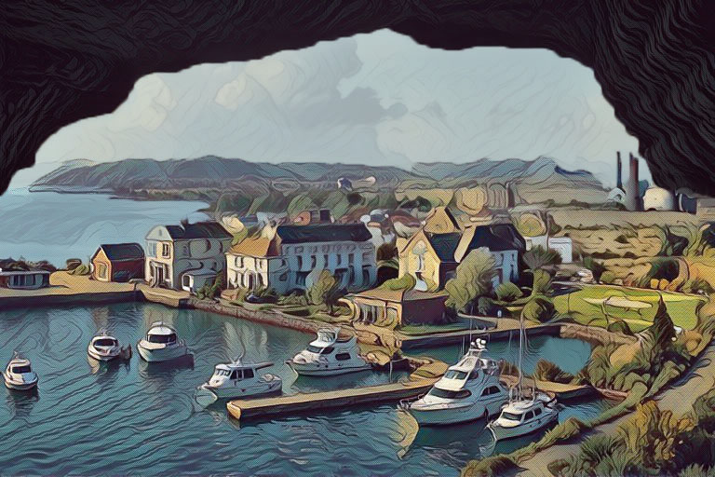

"Wow!" said Andrew.
"It's all so beautiful!" agreed Jennifer.
Ernor was looking thoughtful. "I wonder what the danger might be?" It shook the others back to reality. Danger?
"This is the first of the trials," reminded Tal. "Let’s go."
They emerged into the sunlight, and scrambled down a short crumbling slope to the path below. It took a further hour's walk in the hot sun, dodging between the bushes to avoid being seen, before they finally reached the harbour. By now it was early evening here. They were passing one of the boats when a capped head suddenly appeared from over the bow.
"Ahoy there!"
They were too startled to answer. There was no need. The stranger was far too persistent to let them go.
"Come on up! Join the fun!" Deciding that there was little to lose, they climbed up the gangway to join him. Anyway, it was about time to meet the locals.
Clambering over to the stern, they found quite a social gathering in progress. At first the travellers were met with a few cold and suspicious glances, but it was a friendly enough crowd, and soon they were accepted as if old friends.
It proved to be a most enjoyable evening, listening to the chit chat and gossip. Snacks were available in plenty, along with a never ending supply of sweet wines and juice. They learned that the town was called Newburg. It had grown significantly over the past few decades, becoming a prestigious residential area and avoiding the trap of sprawling expansion, so often resulting in the decaying inner suburbs of older towns.. It had developed on the site of an old trading settlement which had made use of the natural harbour. Inland, the traditional leather and linen industries were still the basis for the region’s wealth, although shipping had long since been redirected to a new port some miles away.
Gradually the visitors learned something of the local way of life, which was leisurely and uncomplicated by the need for heavy work. It seemed that everyone in Newburg was so wealthy, although it was difficult to understand how this could be. But why should they care? It was a relief just to take it easy for a change.
They were having a marvellous time, and at the end of the evening were thrilled to accept their host's offer to stay on board. They were even offered overshirts with a 'crew' logo on the front, which proved popular with the other guests on the boat, but Andrew was the only one who would wear it.
The cabins were very luxurious, much larger than you might expect even for a large boat. For a while they lay awake, thinking of all the lovely things they could see and do in this place. The night was calm and peaceful, only much later interrupted by the sound of distant clunking engines, although by then no one remained conscious to hear them.
For three days they stayed, using the boat as a base to explore the surrounding gardens and monuments or just hanging around the harbour and gardens. It was a wonderful way to live, with each day as enjoyable as the last. So much had been achieved, despite the slow pace of life. Every hour was taken up by sightseeing and play, with all needs and comforts being provided by their most generous host.
Each night they returned to the boat, until gradually all had heard the distant sound, and their curiosity grew so strong that they argued about what it might be, and became determined to find out. Repeatedly they challenged the captain, but he would only avoid such questioning, and quickly changed the subject. Eventually they decided that they could wait no longer, and told him of their intention to investigate during the night.
His reaction was surprisingly intense, turning quite red with irritation, and insisting that they mustn't go. Despite their requests for a reason, however, he would only repeat that no, it wouldn't be safe, and that it was none of their business anyway.
Still they were not prisoners, and were free to go where and whenever they wanted. They had been brought to this land on a mission, and any secrets had to be investigated. So, in the evening, after their host had bidden farewell to his guests and retired, four figures stealthily crept away from the boat to see what they could find.
They walked for a long time, shivering out in the cold night breeze, before the mechanical thumping could again be heard in the distance. But from where? At times it seemed to come from the old town, at others from back in the mountains. Not knowing source from echo, they wandered on, changing direction with the wind.
Eventually they realised exactly were the sound was coming from. Although still a long way off, faint lights could be seen shimmering through the clear night air.

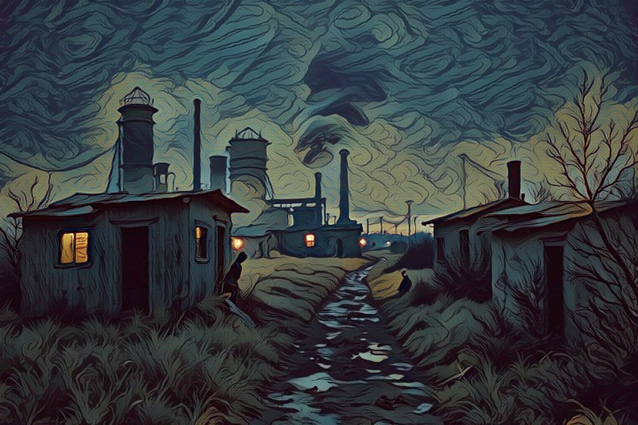

It must have taken over an hour trudging through the damp scrub before they would reach the outskirts of the derelict town. As they approached, moving figures could be picked out amongst some sheds, the subdued moon just highlighting shapes carrying sacks and loading carts. They had to get closer to the main buildings, so they skirted around the sheds to avoid being seen. Dodging between long-abandoned warehouses, they were never seen as they managed to reach one of the larger buildings that was occupied. The windows were dirty, and almost opaque with condensation, but between the streaks and smears they could just make out what was going on.
Inside, it was crammed with creatures, bodies stooped over machines or pushing trolleys, all dressed alike in dark grey overalls, well worn and ragged. The room was filled with steam, and with the sound of a score of small engines and people shouting. It was just possible to make out what was happening.
They were making clothes, of such quality as had been commonplace in the city, but which seemed so out of place here. Amongst all of these creatures could then be seen another, uniformed and obviously bearing some authority. One creature moved as if to strike him as he pushed his way past, but was swiftly and quietly restrained by his friends. The hatred was difficult to hide, and it was easy to read their lips for the unspoken words. "Not now."
There was no sense in staying too long, and so they retreated, still clinging to the shadows of the derelict buildings. The factory that they had seen was only one of dozens.
"I wonder what they make in the others?" pondered Andrew.
"More clothing, I should think," replied Ernor. "As well as shoes, furniture, that sort of thing. This is where the exports come from."
"Why is it so awful" asked Jennifer.
No one answered. The long walk through the park and back to the boat was made in almost total silence, although few thoughts wandered from what they had just seen.
The next day they rose late, but were relieved to find that their host was quite unaware of the previous night's expedition.
The best part of the day was spent in debate, although the subject was carefully avoided in his presence, not knowing what the reaction might be. It was only later that evening that they finally plucked up the courage to ask him for an explanation.
He was obviously very upset, although the immediate response was stifled. "I asked you to keep away from that place. It's best not to ask too much. The menials are dangerous. You can't trust them, you know. They'll rob you the first chance they get, or worse." He stared hard, his eyes desperately pleading with them to understand.
Tal wasn't happy. "How do you keep them there? Are they your slaves?"
"Certainly not! They can leave any time they like. They're lucky we give them any work at all. The best of them can even become supervisors, and have a very good life, with a nice house at the edge of the old town. It's just that most of them couldn't do any better if they tried. They're just idle and useless. Lucky to be given a job at all."
"And so what would happen if they didn't want to work for you?" pursued Ernor.
"No problem. They're not forced to work. Of course, they'd have to go back to the scrublands, where they came from. But they just can't take care of themselves, you know. They need us to look after them. Stop worrying. They're not worth it."
Tal still felt uncomfortable. Perhaps he was right and they couldn’t be trusted. But perhaps respect and friendship needed to work both ways and they were left with so little. "It's not right to use people like that."
The captain finally lost his patience. "What's the matter with you? You come here, sleep in my boat, eat my food. Is this how you repay hospitality? What are you anyway, anarchists? The menials are not slaves. We give them work, a place to live..."
Tal bowed his head, then turned to walk away. There was no point in arguing. "We have to go."
A loud yell startled everyone. They turned around, to find the captain shouting, holding a rifle pointed in their direction. Tal rushed up and pushed him off balance, knocking the rifle out of his hand as he toppled heavily backwards into the water.
By this time, a small crowd had begun to gather, and there was no doubt that these were not the same friendly glances that the visitors had become used to. There was no time to discuss the matter any further. Instinctively they ran as fast as they could towards the park and the cover of the bushes, away from the shouting, angry crowd, zig-zagging their way through the shrubbery, not daring to look behind or slow down until they were quite out of breath.
Now it was getting quite late, and the cloak of darkness would be a friend. At last they could afford to recover their breath, and consider what to do next.
It became a very dark, cold night, the half moon rarely appearing from behind the dense cloud. It was also very quiet, so that even their whispers seemed harsh against the stillness, until once more the sounds of the old town could be heard. But then too came the unwelcome sound of voices behind them, quickly getting louder and nearer all the time. They decided to hide until the danger had passed, and were glad that they did when they overheard what was being said.
"They mustn't be allowed to get away."
"We don't even know that they're here. They could be back in Newburg, while we're going round in circles."
"Even if they are, there's no way out. Only through the scrubland or onto one of the boats. Either way we'll get them by tomorrow."
"So why not leave it till tomorrow? We can organise a full search then."
"No, I won't rest until I've got them. We fought to make this land. We'll fight to keep it. I'll not let those nuisances get away to stir up any trouble." The voices faded away into the distance.
Now the travellers were fugitives once more, and it was obvious that they could never go back. They had to get away, and the cave was their only hope. But which way to go? They had lost all sense of direction some time ago, but then they recognised something in the distance. It was the shimmering lights of the factories.
"That's where," said Tal. "We'll find our way back to the hill from there."
It didn't take that long to reach the old town again, despite stumbling over the uneven ground and bumping into bushes in the darkness. As they approached the buildings, it seemed that there was more activity than before. More menials were loading carts with an increased urgency, to be driven away as soon as they were full.
Tal was curious. "Let's get closer, I want to see what’s going on."
"Why?" asked Ernor. "We must get back to the cave. There's no point in staying here."
"I'm not sure. There's something I just want to see. You can wait back here if you like."
But they wouldn't let him go alone, and before too long they were all hiding behind one of the derelict warehouses just outside the town centre. From here they could easily see what was going on and now understood the reason for Tal's interest. The menials were loading guns onto the wagons!
"Why are they doing that?" asked Andrew.
"Isn't it obvious," replied Tal.
"Had to happen sooner or later," added Ernor, sadly. "Perhaps we'd better get back and warn the others."
"But we can't. We'll be shot on sight."
"Even so," continued Ernor, "we must do what we can."
The group retreated to a safe distance, and started to argue over what to do next. There was little sympathy left for the Newburg dwellers, but no-one wanted them to be hurt. But now it seemed too late to do anything. Even if they reached them in time, who would listen to them? They would only be accused of starting the revolt. Again, if they went to the old town to try and stop the trouble, who would listen?
"If only we hadn't taken so long to question what was going on." Said Ernor.
Then there was the muffled sound of an explosion, and a red glow could be seen on the horizon. At first low and dim, but then growing brighter, and higher, until the entire distant sky was alight.
There was nothing they could do, and they knew that both sides could only lose. It was beginning to rain, as if nature itself needed to share their misery. There was only one direction left to go, and Ernor voiced the single thought that was shared between them.
"We could have stayed. We could have stayed and lived here in comfort and accepted it all. And then we might all have been killed."

Chapter Eight

The Drowwlen

They returned to the cave cold and shaking, for it had been raining hard. It was enough to sleep just inside the entrance that night, being impossible to stumble down the tunnel in the blackness. Despite everyone’s exhaustion, it was a restless night, with the distant crack of gunfire continuing almost until dawn. The element of surprise should have favoured the menials, but they could be no match for the power of the Newburg dwellers. Finally the noise subsided. Perhaps the uprising had been crushed, or perhaps there was no-one left to share the wealth that could once have been enough for all.
The following morning found the town still standing, in the distance its grandeur barely tarnished, despite expectations. At first glance, the only indications of any struggle were the scattered wisps of smoke pinpointing the smouldering remains of distant fires. Nothing else seemed out of place. Nothing, that was, until one looked further out to sea, which was speckled white.
Perhaps it was only birds, or perhaps waves. Then, slowly, the truth dawned. This was an armada, an exodus on a vast scale, with possibly a hundred boats. For many had escaped, deciding that there was nothing left worth fighting for. The travellers looked on in helpless silence, very sad, yet so glad that it was all over.
By now it was light enough to make the way back to the chamber, a short journey, being downhill. The machine was again activated, humming in the intensity of light.
Little deliberation was needed this time as the adventurers took the next opening.
The light from this was not so bright, so it was much more difficult to see the ground, the lower half of the tunnel being hidden in shadow. Progress was consequently slow, and all took turns to complain of twisted ankles or grazes.
Suddenly Tal, who was leading the way, cried out as he fell forward. The group stumbled to a halt, but the warning had come too late. In a dry, earthy quicksand they were sinking, until, with a final crash, they fell straight through the floor and onto each other in a crumpled heap.
It was a few moments before anyone recovered enough to realise what had happened. They were in yet another tunnel, lower and darker than the last, or at least serviced by a different, mellower type of light. Around was nothing but solid rock, even above, from were they had fallen. Covered in dirt, scratched and bruised, they scrambled to their feet. But they could not be alone.
From somewhere nearby came a shrill, piercing howl, and it was getting closer. Momentarily they froze, petrified as one with the cold stone around them.
Then they ran, fleeing in a desperate attempt to leave their terror behind.
The further they ran, the higher and brighter the tunnel became, but there was still no time to question whether they were being followed.
The chase ended as abruptly as the tunnel. This was not just a room, or even a cavern, but a vast expanse, with a ceiling so high that it was lost in a bright haze. Small trees and bushes grew around, whilst here and there a vine dangled out of nowhere, as if an Indian rope trick. The effect was spectacular. The pale hue of light showed no source, but blended into the pastel shades of vegetation.
"Shhhh," said Ernor.
Everyone went very quiet, listening hard, but to no result. Without so much as a breeze, the stillness surrounding them was absolute. If the plants grew, you would have heard it.
Ernor seemed on edge. "We're being watched."
They meandered along paths which led through several shrubs and vines, not wishing to retreat, but hoping against hope that there would be some other way out.
Eventually one path led to a small stone table, upon which lay a sumptuous selection of food and drink, a mouth-watering mixture of fruit and cold dishes, richly coloured and aromatic, such as none had seen before.
"Don't touch it," warned Ernor. "It may not be safe." It was good advice, but the smell was delicious, and drew them irresistibly forward. They stood before the table in admiration.
"Of course we can't eat it," said Jennifer, "but it does smell wonderful." She picked a bunch of small red berries from the top.
There was a crack, and a whoosh as they felt their feet being swept away from underneath. Before anyone could escape, they had been turned upside down, squashed tightly against each other, swinging some five feet off the ground. The net cut into their faces and into their bodies, crushing any hope of movement.
It had been a shock, but now they were just exhausted and angry.
Almost instinctively they knew that a crowd had gathered below them. By twisting heads against the cutting ropes, it was just possible to make out what was happening.
A score or more gaunt faces looked upwards, whilst a gathered mat of spindly arms bristled excitedly, waving large sticks in the air.
A path cleared as the leader approached. Gradually the noise subdued. He raised his arm, and the net was lowered to the ground. With considerable difficulty the travellers managed to untangle themselves, then rose to their feet.
"What are you? How did you come here, and why?"
Tal just scowled. "Who are you to ask?"
Ernor too was feeling exhausted and annoyed, but decided that co-operation might be wiser. "We've just come down from the outside."
"Lies! There is no way!" snatched back the creature. "We know you are servants of the Beast."
"I've had enough of this," declared an exasperated Tal as he took a step towards the leader. At once the other creatures closed ranks in protection, brandishing their fists and sticks.
Tal reached out an arm to brush them aside.
He had hardly touched them, just to push them back in self-defence. Astonishingly, even this sent bodies flying across the floor. Sticks snapped in his grasp, some even crumbling to splinters. The creatures cowered back in surprise. None was seriously hurt, but such strength had never been encountered before, and their fear and bewilderment was evident.
For Tal's part, he was equally astonished. Despite their hostility, the creatures had never looked very strong, but such lightness and fragility had taken him completely unawares. He drew back from the sorry sight of cowering would-be warriors.
Moments ago, armed to the teeth, they had seemed so fierce, but now so vulnerable that even the furious Tal took pity.
The leader fell to the floor in supplication. "Please do not kill us."
"We have never meant you any harm. Why did you trap us like that?"
"Your master kills our brothers, yet you mean us no harm? What trick is this?"
"We have no master," snapped Ernor, "We came from above. I don't know who you think we are, but this place is quite new to us. All we want is to get out of here."
"Out? Back to the catacombs? There is nowhere else. You must be servants of the Beast."
It was impossible to convince him. Despite all efforts, they did not want to believe that the world extended beyond their own subterranean universe.
Contact with outside was beyond their experience, and could not be an acceptable answer. Tal finally had to accept that there was no argument that would win, and instead demanded that the creatures gave an account of themselves.
"This is the land of the Drowwlen," answered the leader. "Here...''
"But that isn't possible!" exclaimed Ernor. Tal looked equally astonished, but at first the children didn't remember why. "The Drowwlen were the Great Civilisation," he explained, mainly for the children's benefit. "It was they who wrote the manuscripts, who are responsible for our being here. We were always told that they had destroyed themselves, aeons ago."
Such revelations were lost on the tribe, who couldn't begin to understand what Ernor was saying. To the travellers, it was amazing even to consider that that this feeble frightened group was now all that remained of the proudest people ever known, a race with such strength and knowledge that had surpassed anything before or found since.
For the rest of that day the Drowwlen played out the role of unwilling hosts to their visitors. Together they toured some of the local settlements, rows upon rows of bivouac lodgings which offered little shelter and even less privacy.
Despite several hours' walking, no evidence was found of another exit. The Drowwlen remained adamant that no such route existed. It was quite impossible to prove given the immensity of the area, but there seemed no reason for the Drowwlen to lie.
Surprisingly, none had ever actually seen the Beast, and only a few of those present had ever been in the catacombs. Its roar had often been heard, and many traps had been set, but all without success.
Some had ventured near the entrance, and thrown their spears wildly towards a sound in the darkness. Over the years, some Drowwlen had even entered the tunnels, the curious venturing to see what lay beyond, or the foolhardy attempting to prove their courage. But of those, not one had ever returned, and were all presumed to have fallen to the Beast.
But if there was no way to leave, for many there was little reason, for so much was provided. A never-ending variety of luscious fruits came from more orchards than the travellers could ever have thought possible. It was often difficult to remember that this was all happening below ground, and that beyond the bright glow above was not the sky, but hard stone. The light was much softer than daylight could ever be, but it was continuous.
The only change in the climate occurred at precise intervals, when a gentle rain fell, but only over the orchards.
As they walked, the Drowwlen collected some of the fruits. There was obviously much more food than they could possibly need, which must have made it an easy, if rather tedious existence.
Perhaps it would have been good to stay for a few days, but there seemed little point in overstaying their welcome, such as it was, and so the first thing next morning, the travellers decided to try to find their way back. By now they were convinced that there was no choice but to leave by the same route that had brought them.
This should have been worrying, especially since no Drowwlen was prepared to help for fear of the Beast, but they were now feeling rather braver than they might. The Drowwlen had turned out to be so weak, that almost anything would terrify them. Perhaps this Beast's roar was more frightening than it deserved.
At least this time they were fully prepared, now bearing a torch, and of course a satchel of fruits, together with a large flagon of water. The brothers also took a knife each for protection.
Hoping that they remembered the way, they hurried back down the tunnel. As expected, the passage narrowed, and the light grew dimmer. Soon they were forced to stoop, and it became necessary to use the torch, which proved difficult, as it took several attempts at striking flints against the stone walls before the sparks caught.
Then it became really dark, and everyone huddled as close to Tal (the torch- bearer) as they could. Nervously they edged their way, often convinced that they could hear something.
Frequently all would stop, not daring to breathe as they listened. Time after time it was nothing, probably no more than the echo of their own soft footsteps.

When it happened they were still taken totally by surprise.
No distant growl, but a roar which must have been only steps away. Tal almost dropped the torch in shock as they stumbled backwards into each other. His wits recovered enough to hold onto the light, and then they saw what they were facing.
A blur of matted fur swept before them. The torch was knocked to the ground, where mercifully it remained lit. Scrambling over each other, they crawled out of reach from the Beast, but not from the light.
With another roar the Beast fell from its full height onto all fours, backing away into the shadows. For some time it crawled around the far side of the light, pawing at the stone.
The roar had now reduced to an occasional whine. This Beast was obviously as frightened as they were. It was also having considerable difficulty in moving.



"Why, it's only a bear!" whispered Jennifer, in relief.
"Maybe, but they can be very dangerous. Stay clear of it," warned Andrew. The brothers had never seen a bear before, or even heard of such a thing. To them this was a monster, which had to be destroyed. Tal slowly approached, drawing his blade.
"Come back! Leave it alone!"
Jennifer had realised why the bear could not attack. The poor animal had already been crippled by a trap, and the rusty remains of an iron snare still pierced one leg. The Beast could hardly move in its agony.
She pulled at Tal's arm. "Don't hurt him any more."
Andrew took a cautious step, but again the bear reared backwards, roaring defiantly, not knowing that he only wanted to help.
Years of hatred had taught nothing of kindness. A lifetime of being hunted mercilessly, suffering the wounds of spears and knives thrown by unseen tormentors, had left only fear and distrust. Never daring to venture into the light for fear of capture, it had been maimed by a cruel trap, tearing into his flesh as he tried to get free. But now the trap had been broken, and the Beast turned and dragged itself away deeper into the labyrinth.
Fatally wounded, now it could only return to its most secret sanctuary, there to starve and slowly die.
The whining of the Beast had long since faded, and it seemed safe once more to continue. The tunnel became smaller still, and the rocks above were now so close that all but Jennifer had to adopt a half stoop, which quickly became very uncomfortable. From the last chamber, they had not really travelled that far, yet it seemed to be going on forever. Still no-one voiced their greatest fear - that perhaps there was no way out from this place after all.
Tal was the first to emerge into a small cavern, and held the torch high for the others to follow. One by one they scrambled out, heaving great sighs of relief as they finally managed to straighten up again. They blinked in the light of the torch, then stopped dead in their tracks. In the centre of the cavern lay a motionless mound of fur. The bear had finally collapsed from exhaustion and pain.
Very slowly and carefully they approached, ready to flee at the slightest movement. None occurred. As they bent over the poor Beast, they could see that it was hardly breathing. Short feeble panting was the only movement, but at least this meant that it was still alive, for the moment.
"I wish there was something we could do," said Jennifer, bending over bravely to smooth down some matted fur.
"But there is," insisted Ernor. "We could free it from the snare."
"It would still die."
"Probably, but it might be easier."
Tal reached over and matched the grip of the rusted mechanism with his strong hands. With an almighty heave he pulled it apart, snapping the metal in two. The leg was freed, but the bear didn't move. Andrew saw how badly it was bleeding, so took off his overshirt, and offered it to Tal.
"Use this," he volunteered. "I'm too warm anyway."
Tal took the shirt and tore it into several strips. It should really have been a lot cleaner, but one sleeve wasn't so bad, and Tal applied this first. It took a long time and a great deal of care to apply the bandage, made all the more difficult by the weight of the Beast. When he had finished, Jennifer poured some of their water into a hollowed-out stone, and left some fruit close by, just in case.
The Beast was a pathetic sight, but perhaps now it seemed more at ease. There was no more that could be done, and the travellers had again taken more time than they would have liked. Luckily their torch was still burning strong, but it wouldn't last forever.
Another tunnel (even smaller than the last) was on the other side of the chamber. This time they were all forced to crouch in order to enter, which of course proved to be an extremely uncomfortable way to move for very long, so soon all were complaining of aching backs. Every few minutes they were forced to stop and rest, to kneel or sit as room allowed, which made progress very slow. The tunnel began to slope downwards. Was it their imagination, or did the air seem fresher? At first it was just a gentle slope, but gradually it became steeper and steeper.
It also became smaller and lower, until they were forced to crawl on all fours in order to continue. The feeling of such acute confinement made them want to explode, to break out into the open again as quickly as possible. Each would willingly have given up at that point, returning to the open spaces of the Drowwlen, were it not for the cool gentle breeze which brought a new excitement as it brushed their faces and fanned the flame.
Suddenly excitement turned to panic. Close behind came a heavy pounding, accompanied by a terrifying howl. They tried to stop, but now the tunnel was too steep. One after the other they slipped, faster and faster, until with a resounding crash fell through the pitch darkness into a blinding light.

Chapter Nine

The Jewel of Bothex

Eyes strained against the new brilliance. Blurred images of tinsel slowly focused into crystals and gilt. A golden corridor, crowned with chandeliers and lined on both sides by a score of closed doors, was dominated at the far end by a monumental stained glass window. Some noise was coming from the other side.
Behind them yawned a giant open fireplace, grates shining as if never tarnished by use. This was probably true, fortunately for the travellers, for their unseemly entrance through it may otherwise have been even less comfortable. The bear, which had tumbled down after them, was now staggering around aimlessly.
"It can't see a thing!" observed Andrew.
"But what an amazing recovery!" added Tal. "It looks quite fit now. I thought that it was going to die."
"Perhaps we gave it a reason to live," suggested Jennifer. "Perhaps it has never known kindness before."
Andrew just ignored all that mush. Better or not, this was a wild beast, and still dangerous for that.
"Then why was it chasing us?"
"To warn us, perhaps?" suggested Ernor. "Of the danger ahead, I mean."
It seemed unlikely, yet none would leave an animal blind and defenceless. Keeping one eye on the clenched fangs, Tal reached out to stroke the creature's back.
The menacing snarl receded, and a cold snout muzzled into his hand, searching for comfort, and grateful for the reassurance.
From that moment on, nobody had any doubt that this was a friend. Curiosity turned towards the noise outside, and the group made their way down the corridor. Tal grasped a huge golden handle, and the giant window slowly opened. A thunderous roar erupted before them.
Outside was a wide balcony, nothing else could yet be seen. Cautiously they crossed the marble to the low boundary wall, and peered over. Now the source of the commotion was apparent - a surge of people, Rinborch and werroks alike – finally united in their rejection of the coven. No longer accepting to be manipulated into a life without purpose or pride, the revolution had finally been brought about, not by the Calidras, but by those who simply wanted to contribute more and achieve something.
Someone had spotted them, and the anger and abuse reached a fever pitch. Something flew past, shattering one of the windows. It may have been thrown, or perhaps fired; there was no way to tell. In any event, it was convincing enough to make them rush back for cover and the safety of the corridor.
Once inside, there was no option but to take a risk. Now came the decision of which door to try.
The first door was locked, but the second opened easily enough, and gingerly it was nudged ajar. This revealed a large hall, lavishly decorated, but quite empty, without so much as the simplest piece of furniture.
They nudged the third door. This time the sound of whispered conversation confirmed occupation. Through the crack two figures could just be seen, standing upright to attention at the end of a lobby. Behind these towered a formidable double door carved in oak. The figures were in military uniform, both very tall, and dressed in highly polished chain mail. Bright metallic pointed helmets shone in the sunlight, which fell as a beacon from the windows high above.
The guards seemed to be very nervous, and almost dropped their pikes when a loud trumpet blast preceded a heavy thump on the doors, which then opened in perfect unison. A tall, beautiful Rinborch appeared in the doorway. She wore the most exquisite gown of velvets and silk, with sparkling stones embroidered along seams. Around her neck was a single golden necklace, and on this hung a gem as large as a clenched fist.
"Don't look!" hissed Ernor, as he pulled the children away from the door. But it was already too late. Jennifer struggled out of his grasp, pushing the door wide open.
Startled by Jennifer's entrance, the guards immediately surrounded their mistress. The Rinborch tossed back her head, and swept them both out of her way. She stood tall and fearless against the intrusion, holding the now incandescent gem before her.
"Come here, little creature." This was a voice that expected obedience. Jennifer yielded, in solemn silence, her eyes fixed only by the jewel.
"Who are you?
Jennifer answered. There was no hesitation.
"Are you alone?"
"No, there are four of us." Jennifer pointed to the door.
Andrew could hardly believe his ears, although the others well understood what was happening. There wasn't a moment to lose. Tal dragged Andrew to his feet, and all three ran as fast as they could down the corridor, the guards in close pursuit. They raced past the doors, every now and then wasting valuable seconds to try one that never opened.
Before long they had reached the fireplace again. Time had run out.
The guards were now in the corridor, pikes held as spears above their heads. The nearest door was also locked, but with a desperate tug, Tal managed to free an enormous bolt and push his way through.
The three rushed in, but immediately their feet gave way as the floor disappeared beneath. Falling, heavily and hard, bumping and scraping painfully against sharp angles of stone. Tumbling over and over, and finally coming to rest at the foot of a long flight of steps. They looked up to see two jeering faces disappearing as the door slammed above them. The hollow thud echoed its dreadful message. They were prisoners.
As their eyes became accustomed to the half-light, it was apparent that they were not alone. All around, several groups were concentrated on various tasks - mending, making or sewing - whilst guards strutted about to ensure that there was no chance of rest or disruption. One approached, and thrust the new prisoners towards a bench. With a wry smile he threw some rags towards them, and pointed to a mound of dry and dirty leather.
Both brothers were well used to cleaning livery. It could have been much worse. Little was said as Andrew followed their example carefully. There was much to clean, and time enough to take note of their surroundings.
The stairway was almost certainly the only exit. Holes high in the walls provided ventilation, such as it was, but these were well barred. The air was very damp. Water droplets splashed onto the floor from the ceiling high above, the upper reaches of the walls thick with green mildew. Many of the inmates appeared sickly and coughed frequently. One group in a distant corner seemed particularly weak, coughing more than all of the others, which only infuriated their guards. After a while the truth became apparent. These were not werroks. This had become the fate of the missing Drowwlen.
Ernor turned to his brother, and whispered in his ear. "This is it. We can't get out of here." A short smile was exchanged, one that accepted the truth, but held no fear. Andrew neither saw nor heard.
At the time that the guards were chasing the three down the corridor, the Rinborch beckoned Jennifer forward, caressing her hair as something quite extraordinary. She spoke slowly, with a low, slightly grating voice.
"My dear, you are just what We need for a handmaiden. Unusual, certainly, but still you have some qualities. Yes, you will do nicely." As she spoke, the jewel shone. Jennifer could only stay fixed to the full force of its brilliance. If only she had been left with the power of her own reason, she would surely have realised by now that this was the Witch Herself. But freedom of thought was impossible whilst under the spell of the Jewel of Bothex.
The Witch showed the greatest interest after the fleeing intruders, Jennifer complying with the protracted questioning. "That's very interesting. This, we think, is something of an opportunity. Yes, an opportunity indeed!"
"But if it pleases Your Majesty," stammered one of her attendants. "The rabble are still outside. We must do something soon. That is, if Your Majesty pleases, of course..."
"Quiet, fool! You suppose that We cannot control them, disperse them, destroy them! At any time! But We choose not to, for now. No, they will wait until tomorrow. We have a surprise for them then! Tonight, We dine, We sleep. They wait." With that, she swept out of the hall, trailing her long gown and entourage, Jennifer included.
**********
The long night had done nothing to temper the crowd's hostility. The chanting was as strong as ever, although it seemed that the Witch was quite oblivious to the noise. She had risen shortly after dawn, and then called the full guard to the front of the palace.
Throwing open one of the great windows, there was no concern in her expression, no fear that showed in any movement. She stood motionless as an ice statue in the centre of the balcony, whilst her attendants kept a respectful and prudent distance behind. The jeering increased again to fever pitch, and another of the windows shattered.
"Enough!" She held out one hand, and the noise subsided. The Jewel shone in a thousand colours, charged by the brightness of the rising sun. The other hand beckoned to the guards. "Bring!"
On the command, Tal and Ernor were brought forward. They had already been taken from their prison on the Witches command, and were now thrown heavily and painfully forward onto their knees, with hands bound tightly behind their backs. Without turning, the Witch continued her address.

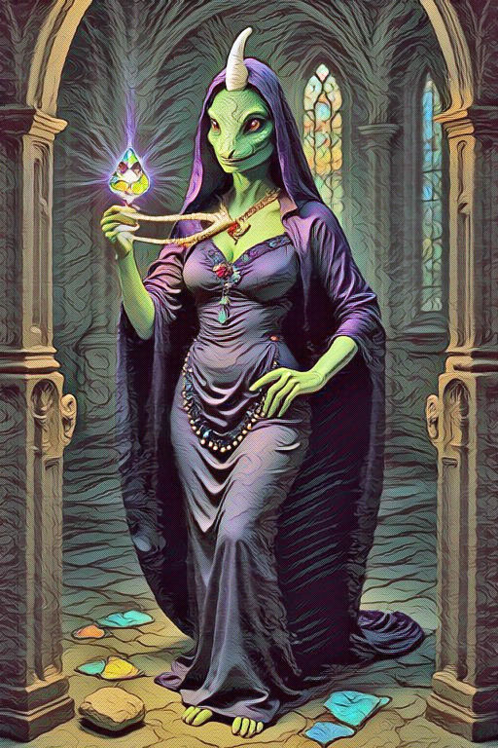

"So, defy us, would you? You must learn that We have the power, and thereby the right." With this she raised the Jewel high above her head. Everyone cowered, trying to shield their eyes from its captivating sight, but to no avail.
"Fools! Would you return to the days of a feeble ruler without strength and power, there for the taking? Would you still have Odeiyon in my place? See his sons! Witness their miserable weakness! Their life is now in my hands, and their fate will you decide."
She pulled Ernor towards her, forcing back his head as she did so. He struggled in vain as unyielding bonds cut into open wounds. Again she turned to the crowd, the Jewel magnifying the intensity of her will.
"What would you have me do?"
With awful inevitability the response was as one. "Kill him!" The trance was now complete, as the chant grew ever louder. "Kill him!"
Seizing a sword, she held it menacingly above Ernor's head. He could not even flinch, his eyes transfixed by the Jewel. At first Tal struggled desperately to help, before he too was captivated, and could only watch in silent desperation. There was now nothing that he could do to save his brother. Still the chanting continued, as the sword began to lower.
For a while it was as if time itself had stopped.
Suddenly there was a roar, and a scream as the Jewel flew high into the air. The Witch had been unceremoniously thrown backwards, as a flash of fur swept before them. In one moment, a debt had been settled by one too blind to be captivated by mere beauty.
The Jewel dropped onto the edge of the balcony, and there it shattered into a thousand pieces.
Gradually the crowd wakened from their hypnotic state, and started cheering. Pieces of Jewel were lying everywhere, to be eagerly gathered in a scramble of hands. Andrew rushed forward to help Ernor, cutting him loose.
The Witch was now recovering. Still half dazed, she rose shakily to her feet, still regal, but now looking so fragile. Along with her subjects, she too had been captivated, and now freed. The power of Bothex had gone forever, as had the cold, hard stare so feared by her subjects. Only poise and dignity remained.
Once more she spoke to the crowd, but this time without harshness. Instead there was the humility of one who had accepted fate, and understood it to be for the good.
''The Jewel is now gone. What would you have me to do?''

Chapter Ten

Resolution

Again the chant, but this time, growing ever louder, "Kill her... kill her."
Tal pulled her back and faced the crowd. "You know that way has failed before. It is not the answer here. She was as much held captive by the Jewel as you were."
By this time, one werrok had succeeded in climbing onto the edge of the balcony, waving a rifle high in the air. It was easy to recognise him as one of the Calidras. His face was red with excitement as he called at the top of his voice.
"We demand justice! We demand freedom! Give us back our respect!"
"You now have your freedom. Respect is not for the asking."
It was a reply worthy of the Doonby. Ernor had learned much, but the Calidras would not be calmed so easily.
"The time for the werrok has finally arrived. Already we have waited too long. Kill the Rinborch! Kill them all! We must win now!"
Again cheering from the crowd, but by now some Rinborch had grouped, and one was pushed forward to challenge him.
"We will never give up our heritage. What is ours will be defended with our blood - and yours!"
"You must surrender to us now! There is no other way. Move aside, or die."
The situation was rapidly worsening, but Ernor's mind was clear. Perhaps he had learned something from the trials after all, or perhaps it was the sharpened senses of one who had just been so close to death. In any event, to him the truth had now become certain, no longer merely feelings of right and wrong, but a strength of conviction which had finally come with wisdom. To everyone's surprise (and not the least his own) he stood forward to take command of the situation.
"This is all pointless. We must live together now, werroks and Rinborch. There must be no more killing. It will never be right, no matter the cause under which it is excused."
But hatred dulls the senses, and the Calidras had fought too hard to let this moment pass so easily.
"You can’t stop us now. If the Rinborch do not surrender, then we will kill them. We have suffered enough in their hands. Revenge is ours. Now the power of the Coven has gone, and we will take control."
It was clear that the Calidras were only manipulating fervour in order to achieve their own goals. Realising their intent, Tal tried to rally the crowd back to reason.
"No, he is wrong. We could fight, and, of course, those who survive would have the wealth. But we know there is never enough, and what is our goal then? More power? More bloodshed? There has to be something that is more important than anything we can simply own, something more complete. That should be our true goal, and to find it we must be prepared to help each other. Perhaps the Doonby can guide us, or perhaps we can learn from our history. But first we must all share in one hope. The heart has to return to Dococulouck."
"But we have heard all this nonsense before, and nothing has happened. Why should we trust you, Tal? Because you are the son of Odeiyon? How do we even know that that is true? This may all be yet another trick."
It seemed hopeless to argue. Too many lies had left their bitter legacy, but Ernor was inspired. He picked up the sword that so nearly ended his life, and came forward to address the leaders.
"By this you may judge the truth." Reaching up, he laid the sword to rest on a stone above the balcony.
"And here it will stay, for a thousand days and a thousand nights. Then we will return, all of us, and meet again, Rinborch and werrok, and you will be our judge. We cannot promise that everything in Dococulouck will be perfect, without envy or greed, but we will all be free from those who have ruled through deceit. We will start to introduce a fairer system. I promise this. If, when we then meet, you do not accept that hope and truth have begun to return to Dococulouck, then together we will choose new leaders, or my life is willingly forfeit. No-one can promise more."
There was no time for the Calidras to respond. Cheers from the crowd, Rinborch and werroks alike, told that Ernor's heartfelt plea had succeeded. The excitement spilled over onto the balcony, where elated guards lifted the brothers, and passed them over to the swarming mass of arms below. There they were passed, from hand to hand, in exuberant triumph as the crowd cheered them on.

In the midst of that commotion there was no way that a lone voice could have been heard, yet both children turned simultaneously towards the distant whisper of their names.
Inside the palace, at the farthest end of the corridor, was a solitary, shrouded, yet unmistakable figure. Bony fingers reached from a billowing sleeve, beckoning them towards a door which they knew had previously been locked. Obediently they returned to the corridor, and followed the figure as he disappeared.
On reaching the appointed door, they were not surprised to find that now it opened easily. There was no sign of the Doonby, but here the noise was sundued. The room was quite bare, but brilliantly lit by a glass dome above, which spanned across the entire room. Fascination turned to excitement as they noticed something that at first glance had been merely a shadow at the far end. It was an opening in the wall. Nervously they entered, and started down the first few steps.
Some glimmer of light could be seen away in the distance. Soon the steps gave way to a stone floor, and once more they found themselves going down a narrow, rocky tunnel.
"Here we go again!" joked Andrew.
Perhaps it should have amazed them, had they stopped to consider what they were doing, that they held no fear down this long, quiet, dark tunnel, with neither Tal nor Ernor for protection. But there was no time to listen to the hollow echoes of their footsteps, or to be frightened by anything that would never be seen. Instead they chattered continuously about the uprising, and of everyone's hopes for the new Dococulouck, now that the house of Odeiyon would rule again.
The tunnel became brighter, and the light nearer, and for some reason it was little wonder that it should seem so familiar.
They were back in the very cavern where the trials had begun. They had emerged from the third tunnel, and there, in the centre of it all, was the machine, and finally the way home.
"I suppose we'd better go now," said Jennifer, eagerly, in a reluctant sort of way.
"Yes, I suppose we must." Andrew pressed the first button, four times, and then the big square one.

The fact that they both woke up on the floor was not really unexpected. That they felt no sense of tiredness was odd, and that their clothes were still (relatively) clean was distinctly peculiar.
Then they saw it.
No humming to be heard. The sun had finally drifted out of reach, so that those few remaining rays barely skimmed across the craggy ceiling. There was just enough light left to see the black box.
That was all, a black box. No display. No equipment. Just a shabby old wooden box, long broken, half buried amongst the leaves and sand.
"But I thought...'' Andrew broke off, looking perplexed. "I thought..." He stopped to wonder for a moment.
"I think I’ve just had an awesome dream."
"About Dococulouck?" asked Jennifer. "And Ernor, and Tal?"
"Yes!"
"I suppose it was a dream," said Jennifer, wistfully.
"Must have been" agreed Andrew. After all, it's not impossible for two people to share a dream. Especially a brother and sister, he thought, brushing down his trousers, as a tiny fragment of Jewel fell onto the floor.



ABOUT THE AUTHOR

Bill Textworth is a pirate of disreputable renown who has spent many years plundering and pillaging (but nothing more naughty than that) on the highest seas, where he gained his terrible notoriety.

OK, his real name is David Higham, a frustrated scribbler of poem and novel, possibly just 12 years old, but is now stuck in the body of a 72 year old. But he does own a nice model of a ship. Sad, but true.

His delusions of piracy have no relevance to this book whatsoever.

He never uses Artificial Intelligence in his writing, as without a soul it lacks inspiration and the ability to be creative. He has used it as a medium for artwork, however, mainly because his own drawing and musical abilities are so very poor. Nevertheless, it has taken thousands (literally) of attempts to create images and tunes that sort of resemble his ideas. And his computer is very slow.

Despite the benefit of using A.I. in a limited way, he is suspicious of the impact of this development in mankind's future. It blends in so well as another tool which can be used to present ideas as if they were facts, to prop up the caricature of truths which seem to be at the core of control behind every government, media and global organisation.

Some people will accept every answer that an A.I. gives to their enquiry, without understanding that it has been programmed to interpret the intention of it's ultimate programmer. Whoever or whatever that might be.

In other words, we believe whatever we are told, until we understand that none of it is true.
An artificial sort of intelligence, you might say.

